Tuning plan for Oracle Database System

# Quick check for database

## Read alert log (db – asm – cluster )

##Log DB

/u01/app/oracle/diag/rdbms/sgn/SGN1/trace/alert_SGN1.log'

##Log DB

/u01/app/grid/diag/asm/+asm/+ASM1/trace/alert_+ASM1.log'

##Log CRS

/u01/app/grid/diag/crs/exax7-01-adm/crs/trace/alert.log'

## I/O - RAM – CPU (server)

Using monitor tool (em13c, am …. )

## Get AWR ( each node)

Using EM13c

## Get ASH ( each node)

## Get 360 edb SQL

# Check Overview for database

## Database Response Time

**How to check**

**Test results**

**Comment**

## Connection Balance

**How to check**

**Test results**

**Comment**

## Average Active Session

**How to check**

**Test results**

**Comment**

## CPU Utilization

**How to check**

**Test results**

**Comment**

## Disk IO Activity

**How to check**

**Test results**

**Comment**

## Logical IO

**How to check**

**Test results**

**Comment**

## Transactions Rate and User Calls

**How to check**

**Test results**

**Comment**

## Oracle database Memory check

### Memory summary

**How to check**

**Test results**

**Comment**

### PGA Memory Statistics

**How to check**

**Test results**

**Comment**

## Redo Transaction Activity

**How to check**

**Test results**

**Comment**

# DBA Maintain job

## Gather job

### Check Gathering Statistics Job

* Check:

SQL> SELECT CLIENT_NAME,STATUS FROM DBA_AUTOTASK_CLIENT;

SQL> SELECT CLIENT_NAME,STATUS FROM DBA_AUTOTASK_TASK;

SQL> SELECT * FROM dba_autotask_client_history;

SQL> select * from DBA_SCHEDULER_WINDOWS;

SQL> select * from DBA_AUTOTASK_JOB_HISTORY;

SQL> select client_name,status from Dba_Autotask_Client;

CLIENT_NAME STATUS

---------------------------------------------------------------- --------

auto optimizer stats collection ENABLED

auto space advisor ENABLED

sql tuning advisor ENABLED

SQL> select client_name,status from DBA_AUTOTASK_TASK;

no rows selected

* Fix:

SQL> @?/rdbms/admin/catmwin.sql

exec dbms_scheduler.set_attribute('MONDAY_WINDOW','DURATION','+000 04:00:00');  
exec dbms_scheduler.set_attribute('TUESDAY_WINDOW','DURATION','+000 04:00:00');  
exec dbms_scheduler.set_attribute('WEDNESDAY_WINDOW','DURATION','+000 04:00:00');  
exec dbms_scheduler.set_attribute('THURSDAY_WINDOW','DURATION','+000 04:00:00');  
exec dbms_scheduler.set_attribute('FRIDAY_WINDOW','DURATION','+000 04:00:00');  
exec dbms_scheduler.set_attribute('SATURDAY_WINDOW','DURATION','+000 20:00:00');  
exec dbms_scheduler.set_attribute('SUNDAY_WINDOW','DURATION','+000 20:00:00');

### Gather manual auto sample database

### Gather manual full database

### Gather manual full schema

### Gather manual schema tables

## House keeping job

# DBA system tuning job

## HugePages Configuration optimization

## Move frequently data to good disk partitions

## Change basic lob to secure file lob

## Exadata Cell nodes FlashCaches mode ( only for exadata)

# DBA application tuning job

## Invalid Objects

## Disable constraint

**Purpose**: Constraints are used for data integrity and consistency. Disabled constraints can lead to inconsistent data.

**Action:** Enable validate or drop these constraints.

## Optimize data transfer through DB Links

**Purpose: Check the effectiveness of DB Links**

**Action: ???**

## Large segments

**Cause**: These segments contribute most to database size. Large table is slow to access if full scan is required.

**Recommendation**: Archive old data or re-organize these segment to optimize size/DML access on tables/indexes.

Team DBA thống nhất quy tắc tạo partition mới cho DWH :

* Những bảng lớn (dung lượng >10G) nên đánh partition (nếu được)
* Chỉ đánh partition theo range hoặc list ( **không nên** đánh theo hash)
* Chỉ đánh partition theo 1 ngày  hoặc 1 tháng hoặc 1 năm ( **không** đánh theo 3 ngày, 7 ngày… )

**Example (DWH)**

|  |  |  |  |
| --- | --- | --- | --- |
| **OWNER** | **SEGMENT_NAME** | **SEGMENT_TYPE** | **GB** |
| **TCB_DWH_VAS** | R312_TAB11F | TABLE PARTITION | 660 |
| **EDW_SOR** | AR_TVR_SMY | TABLE PARTITION | 510 |
| **EDW_DMT** | AR_BHVR_ANL_FCT | TABLE PARTITION | 476 |
| **T24REP** | F_PROTOCOL | TABLE | 388 |
| **T24REP** | FBNK_STMT_ENTRY | TABLE PARTITION | 377 |
| **DWH** | RE_CRF_SBVGL | TABLE PARTITION | 345 |
| **DWH** | PD_BALANCES | TABLE PARTITION | 303 |
| **DWH** | ACCOUNT | TABLE PARTITION | 281 |
| **DWH** | ESB_MESSAGES_OSBV1_QUERY | TABLE PARTITION | 263 |
| **TCB_DWH_VAS** | R310_TAB_2 | TABLE | 260 |
| **EDW_DMT** | AR_BHVR_ANL_FCT_TXN | TABLE PARTITION | 249 |
| **EDW_DMT** | CST_INSIGHT_ANL_FCT | TABLE PARTITION | 248 |
| **EDW_SOR** | AU_SMY | TABLE PARTITION | 236 |
| **EDW_SOR** | PST_ENTR | TABLE PARTITION | 212 |
| **DWH** | LMM_ACCOUNT_BALANCES | TABLE PARTITION | 196 |

## Index

### Rebuild unusable index

Rebuild all ununsable index

### Tables with more than 5 Indexes

### Index with low distinct keys

**Cause**: Following index has low distinct key which may be ineffective for index scan.

**Recommendation**: Consider invisible & drop indexes with low distinct keys.

|  |  |  |  |  |  |
| --- | --- | --- | --- | --- | --- |
| **OWNER** | **TABLE_NAME** | **INDEX_NAME** | **NUM**  **ROWS** | **DISTINCT**  **KEYS** | **LAST_ANALYZED** |
| **EDW_DMT** | AR_DIM | IDX_AR_DIM_END_DT | 8,526,813 | 5 | 08/18/2014 08:36:01 |
| **DWH_QUERY** | TCB_LOY_ACCOU  NT_KBL_1 | TCB_LOY_ACCOUNT_  KBL_1_IND_1 | 4,573,617 | 2 | 01/20/2014 10:21:04 |
| **EDW_DMT** | CST_DIM | IDX_CST_DIM_ID_END  _DT | 3,536,487 | 2 | 07/20/2014 18:40:20 |
| **TCB_DWH_VAS** | MCO_TCB_NEW_  DAILY | IDX_MCO_NEW_DAILY  _YM | 3,272,688 | 1 | 01/15/2014 18:40:42 |
| **DWH_QUERY** | TBL_MCO_2014072  4_CHITIET | IDX_MCO_20140724_CT  _YNGAYBC | 3,135,118 | 1 | 07/28/2014 16:15:22 |
| **EDW_SOR** | ACS_FCY_AR | IDX_ACS_FCY_AR_ID | 2,983,640 | 4 | 08/01/2014 23:58:05 |
| **KRM_ETL** | SBV_CONSOL_KE  Y | SBV_CONSOL_KEY_PR  OC_DATE_IDX | 2,890,211 | 1 | 01/02/2013 00:41:18 |
| **KRM_RPT** | KRM_SYN_PORT_  ALM | PORT_ALM_U_DATA_  DATE | 2,780,365 | 1 | 01/16/2014 17:17:52 |
| **KRM_RPT** | KRM_SYN_PORT_  ALM_0409 | PORT_ALM_U_D_DATE  _0409 | 2,776,433 | 1 | 01/16/2014 17:17:55 |
| **TCB_DWH_CEB2** | ACCOUNTING_TR  ANSACTION | IDX_ACCOUNTING_ST  ATUS | 2,182,286 | 4 | 01/15/2014 17:16:43 |
| **KRM_RPT** | KRM_SYN_R01_AL  M | TEMP_R01_UDATE | 1,250,862 | 1 | 09/16/2013 22:37:55 |
| **KRM_APP** | PORT_TODAY_TM  P1 | PT_TMP1_A01_IDX | 295,779 | 2 | 09/20/2013 23:08:37 |

### Table owner & index owner is different

**Cause**: Following indexes have owner other than table owner:

**Recommendation**: Table owner & index owner should be the same. Recreate indexes with correct owner.

|  |  |  |  |
| --- | --- | --- | --- |
| **TABLE OWNER** | **TABLE NAME** | **INDEX OWNER** | **INDEX NAME** |
| **DWH_BK** | PD_20160719 | T24REP | IDX_PD_20160719 |
| **DWH_QUERY** | CDR_DT_DIM | DWH | IDX_CDR_DI |
| **DWH_QUERY** | TMP_STMT_SESS | T24REP | IDX_TMP_STMT_SESS |
| **EDW_STG** | T_DMT_PD_AR_BSN_MTH | DWH | IDX_T_DMT_PD_AR_MTH_AR_ID |
| **KRM_APP** | KRM_SYN_CAR_BDS | KRM_ETL | CAR_BDS_SO_HDONG_IDX |
| **KRM_APP** | PORT_SOLVENCY | KRM_ETL | PORT_SOL_U_SECTOR_IDX |
| **KRM_APP** | PORT_SOLVENCY | KRM_ETL | SOL_A_LEAD_SYN_IDX |
| **T24REP** | TBL_HBK_ACCOUNT_REGISTER | TCB_LIVE | IDX_HBK_ACCOUNT_REGIS_ACC_MOBI |
| **TCB_DWH_VAS** | MCO_TCB_MM_DETAILS | DWH | MCO_TCB_MM_DETAILS_ALL |

### Redundant index (optional)

**Cause**: These indexes has other superset index which means Oracle can use the superset index for the query. More index will make DML on a table slower.

**Recommendation**: Drop redundant index to reduce overhead on DML & release storage space.

|  |  |  |  |  |
| --- | --- | --- | --- | --- |
| **#** | **TABLE**  **OWNER** | **TABLE NAME** | **REDUNDANT INDEX** | **SUPERSET INDEX** |
| **1** | DWH | FUNDS_TRANSFER | IDX_FT_PROCESSING_DATE  (PROCESSING_DATE) | IDX_FT_PROCESSDATE_CREDITACC  (PROCESSING_DATE:CREDIT_ACCT_NO) |
|  |  |  |  |  |
| **3** | DWH2013 | CATEG_ENTRY | CATEG_BOOKINGDATE  (BOOKING_DATE) | IDX_FACT_CATEG_ENTRY  (BOOKING_DATE:CUSTOMER_NO) |
| **4** | DWH2013 | FUNDS_TRANSFER | IDX_FT_PROCESSING_DATE  (PROCESSING_DATE) | IDX_FT_PROCESSDATE_CREDITACC  (PROCESSING_DATE:CREDIT_ACCT_NO) |
| **5** | DWH2013 | FUNDS_TRANS  FER | IDX_FT_PROCESSING_DATE  (PROCESSING_DATE) | IDX_FT_PROCESSDATE_DEBITACC  (PROCESSING_DATE:DEBIT_ACCT_NO) |
| **6** | DWH2013 | LMM_ACCOUNT_BALANCES | LMM_ACCOUNT_BALANCES_CONT  (BANK_ID:CONTRACT_NUMBER) | PK_LMM  (BANK_ID:CONTRACT_NUMBER:PROCESS_DATE) |
| **7** | DWH2013 | RE_CONSOL_SP  EC_ENTRY | IDX_RCSE_BOOKING_DATE  (BOOKING_DATE) | IDX_RCSE_BKDATE_CUS  (BOOKING_DATE:CUSTOMER_ID) |
| **8** | DWH2013 | STMT_ENTRY | STMT_ENTRY_BOOKING_DATE  (BOOKING_DATE) | IDX_STMT_ENTRY_BD_ACC  (BOOKING_DATE:ACCOUNT_NUMBER) |
| **9** | DWH2013 | STMT_ENTRY | STMT_ENTRY_BOOKING_DATE  (BOOKING_DATE) | IDX_STMT_ENTRY_BD_CUS  (BOOKING_DATE:CUSTOMER_ID) |
| **10** | DWH2014 | CATEG_ENTRY | CATEG_BOOKINGDATE  (BOOKING_DATE) | IDX_FACT_CATEG_ENTRY  (BOOKING_DATE:CUSTOMER_NO) |

### Table partitioned but index non-partitioned

**Cause**: Tables below are partitioned but some of its index is not partition. This is ineffective as index cannot utilize benefit of smaller tree in case index is also partition. Index tree is bigger & when there is maintaining operation, index will be invalid if UPDATE GLOBAL INDEX option is not used.

**Recommendation**: Recreate index with LOCAL option.

## Tuning Top SQL

**Cause**: Any effort of improving performance must involve reviewing the actual SQL code that is submitted in transactions to determine if it can be optimized. The largest performance improvements usually come from tuning the actual code, not from adjusting database parameters. It is important to periodically extract the most resource intensive SQL and examine it for improvement opportunities.

Following SQL statements should be tuned to gain maximum benefits.

### SQL ID bur7zzjmnth3j – Module ODI:1382949750338/7/8487007

INSERT INTO DWH.ACCOUNT_IPL

(BANK_ID, ACCOUNT_NUMBER, CUSTOMER, PRODCAT, ACCOUNT_TITLE_1, ACCOUNT_TITLE_2,

SHORT_TITLE, MNEMONIC, POSITION_TYPE, CURRENCY, CURRENCY_MARKET, LIMIT_REF,

ACCOUNT_OFFICER, OTHER_OFFICER, POSTING_RESTRICT, RECONCILE_ACCT,

INTEREST_LIQU_ACCT, INTEREST_COMP_ACCT, INT_NO_BOOKING, REFERAL_CODE,

WAIVE_LEDGER_FEE, LOCAL_REF, CONDITION_GROUP, INACTIV_MARKER,

OPEN_ACTUAL_BAL, OPEN_CLEARED_BAL, ONLINE_ACTUAL_BAL, ONLINE_CLEARED_BAL,

WORKING_BALANCE, DATE_LAST_CR_CUST, AMNT_LAST_CR_CUST, TRAN_LAST_CR_CUST,

DATE_LAST_CR_AUTO, AMNT_LAST_CR_AUTO, TRAN_LAST_CR_AUTO, DATE_LAST_CR_BANK,

AMNT_LAST_CR_BANK, TRAN_LAST_CR_BANK, DATE_LAST_DR_CUST, AMNT_LAST_DR_CUST,

TRAN_LAST_DR_CUST, DATE_LAST_DR_AUTO, AMNT_LAST_DR_AUTO, TRAN_LAST_DR_AUTO,

DATE_LAST_DR_BANK, AMNT_LAST_DR_BANK, TRAN_LAST_DR_BANK, CAP_DATE_CHARGE,

CAP_DATE_CR_INT, CAP_DATE_C2_INT, CAP_DATE_DR_INT, CAP_DATE_D2_INT,

CAP_BACK_VALUE, ACCR_CHG_CATEG, ACCR_CHG_TRANS, ACCR_CHG_AMOUNT,

ACCR_CHG_SUSP, ACCR_CR_CATEG, ACCR_CR_TRANS, ACCR_CR_AMOUNT, ACCR_CR_SUSP,

ACCR_CR2_CATEG, ACCR_CR2_TRANS, ACCR_CR2_AMOUNT, ACCR_CR2_SUSP,

ACCR_DR_CATEG, ACCR_DR_TRANS, ACCR_DR_AMOUNT, ACCR_DR_SUSP, ACCR_DR2_CATEG,

ACCR_DR2_TRANS, ACCR_DR2_AMOUNT, ACCR_DR2_SUSP, CONSOL_KEY, INT_LIQU_TYPE,

INT_LIQU_ACCT, INT_LIQ_CCY, PASSBOOK, START_YEAR_BAL, OPENING_DATE,

VALUE_DATE, CREDIT_MOVEMENT, DEBIT_MOVEMENT, VALUE_DATED_BAL,

CONTINGENT_BAL_CR, CONTINGENT_BAL_DR, OPEN_CATEGORY, OPEN_VAL_DATED_BAL,

ACCT_CREDIT_INT, ACCT_DEBIT_INT, LINK_TO_LIMIT, CLOSURE_DATE,

LOCKED_WITH_LIMIT, CHARGE_ACCOUNT, CHARGE_CCY, CHARGE_MKT, INTEREST_CCY,

INTEREST_MKT, CON_CHARGE_ACCR, CON_INTEREST_ACCR, ALT_ACCT_TYPE,

ALT_ACCT_ID, PREMIUM_TYPE, CAP_DATE_PRM, PREMIUM_FREQ, APR, JOINT_HOLDER,

RELATION_CODE, JOINT_NOTES, ALLOW_NETTING, LEDG_RECO_WITH, STMT_RECO_WITH,

OUR_EXT_ACCT_NO, RECO_TOLERANCE, PENDING_ID, TOTAL_PENDING,

STOCK_CONTROL_TYPE, SERIAL_NO_FORMAT, AUTO_PAY_ACCT, ORIG_CCY_PAYMENT,

AUTO_REC_CCY, ORIGINAL_ACCT, FROM_DATE, LOCKED_AMOUNT, DISPO_OFFICER,

DISPO_EXEMPT, TAX_SUSPEND, TAX_AT_SETTLE, ICA_MAIN_ACCOUNT,

ICA_DISTRIB_RATIO, ICA_MAIN_ACCT_IND, ICA_DISTRIB_TYPE, ICA_POST_INTEREST,

ICA_MAIN_RATIO, ICA_NEW_MAIN_ACC, ICA_START_DATE, ICA_ADD_REMOVE,

ICA_BACK_VALUE, ICA_MAIN_ACCT, ICA_MAIN_DATE, LIQUIDATION_MODE,

OVERDUE_STATUS, HVT_FLAG, SINGLE_LIMIT, CONTINGENT_INT, ALL_IN_ONE_PRODUCT,

ER_VALUE_DATE, ER_BALANCE, EP_BALANCE, SB_GROUP_ID, OPEN_AVAILABLE_BAL,

AVAILABLE_DATE, AV_AUTH_DB_MVMT, AV_NAU_DB_MVMT, AV_AUTH_CR_MVMT,

AV_NAU_CR_MVMT, AVAILABLE_BAL, FORWARD_MVMTS, CREDIT_CHECK,

AVAILABLE_BAL_UPD, CONSOLIDATE_ENT, MAX_SUB_ACCOUNT, MASTER_ACCOUNT,

LOCK_INC_THIS_MVMT, CLOSED_ONLINE, NEXT_AF_DATE, NEXT_ACCT_CAP,

NEXT_EXP_DATE, DATE_LAST_UPDATE, NEXT_STMT_DATE, EXPOSURE_DATES,

PORTFOLIO_NO, SHADOW_ACCOUNT, FWD_ENTRY_HOLD, FIRST_AF_DATE,

CASH_POOL_GROUP, OPEN_ASSET_TYPE, LAST_COM_CHG_DATE, IC_CHARGE_ID,

IC_NEXT_CAP_DATE, IC_PRODUCT, IC_LST_PROD_CAP, ARRANGEMENT_ID,

ACC_DEB_LIMIT, MANDATE_APPL, MANDATE_REG, MANDATE_RECORD, DR_ADJ_AMOUNT,

DR2_ADJ_AMOUNT, CR_ADJ_AMOUNT, CR2_ADJ_AMOUNT, EVENT, FIELD, OPERAND,

VALUE, MV_ALERT_RES6, MV_ALERT_RES5, MV_ALERT_RES4, MV_ALERT_RES3,

MV_ALERT_RES2, MV_ALERT_RES1, REQUEST_ID, OVERRIDE, RECORD_STATUS, CURR_NO,

INPUTTER, DATE_TIME, AUTHORISER, CO_CODE, DEPT_CODE, AUDITOR_CODE, AUDIT_DATE_TIME, PROCESS_DATE)

VALUES

(:B1, :B2, :B3, :B4, :B5, :B6, :B7, :B8, :B9, :B10, :B11, :B12, :B13, :B14, :B15,

:B16, :B17, :B18, :B19, :B20, :B21, :B22, :B23, :B24, :B25, :B26, :B27,

:B28, :B29, :B30, :B31, :B32, :B33, :B34, :B35, :B36, :B37, :B38, :B39,

:B40, :B41, :B42, :B43, :B44, :B45, :B46, :B47, :B48, :B49, :B50, :B51,

:B52, :B53, :B54, :B55, :B56, :B57, :B58, :B59, :B60, :B61, :B62, :B63,

:B64, :B65, :B66, :B67, :B68, :B69, :B70, :B71, :B72, :B73, :B74, :B75,

:B76, :B77, :B78, :B79, :B80, :B81, :B82, :B83, :B84, :B85, :B86, :B87,

:B88, :B89, :B90, :B91, :B92, :B93, :B94, :B95, :B96, :B97, :B98, :B99,

:B100, :B101, :B102, :B103, :B104, :B105, :B106, :B107, :B108, :B109,

:B110, :B111, :B112, :B113, :B114, :B115, :B116, :B117, :B118, :B119,

:B120, :B121, :B122, :B123, :B124, :B125, :B126, :B127, :B128, :B129,

:B130, :B131, :B132, :B133, :B134, :B135, :B136, :B137, :B138, :B139,

:B140, :B141, :B142, :B143, :B144, :B145, :B146, :B147, :B148, :B149,

:B150, :B151, :B152, :B153, :B154, :B155, :B156, :B157, :B158, :B159,

:B160, :B161, :B162, :B163, :B164, :B165, :B166, :B167, :B168, :B169,

:B170, :B171, :B172, :B173, :B174, :B175, :B176, :B177, :B178, :B179,

:B180, :B181, :B182, :B183, :B184, :B185, :B186, :B187, :B188, :B189,

:B190, :B191, :B192, :B193, :B194, :B195, :B196, :B197, :B198, :B199,

:B200, :B201, :B202, :B203, :B204, :B205, :B206, :B207, :B208, :B209, :B210, :B211, :B212, :B213)

|  |  |  |  |  |  |
| --- | --- | --- | --- | --- | --- |
| EXECUTIONS | ELAPSED  TIME PER  EXEC (S) | %TOTAL | SQL ID | SQL MODULE | SQL TEXT |
| 2,040 | 7.40 | 5.49 | bur7zzjmnth3j | ODI:1382949750338/7/8487007 | INSERT INTO DWH.ACCOUNT_IPL( B... |
| 0 |  | 3.93 | 0j26p05h38btv | ODI:1382949750338/7/7458007 | insert /*+ append */ into DWH_... |
| 0 |  | 3.35 | bfznkpy3atxm1 | ODI:1382949750338/7/7346007 | SELECT /*+DRIVING_SITE(v24)*/ ... |
| 0 |  | 3.25 | 0k66jnv1ymupu | ODI:1382949750338/7/2155002 | update DWH.ECM_MONEYTRANSFER T... |
| 1 | 8,695.30 | 3.16 | fty8ttr7ahz7p | ODI:1382949750338/7/2161002 | update DWH.ECM_SWIFTTRANSACTIO... |

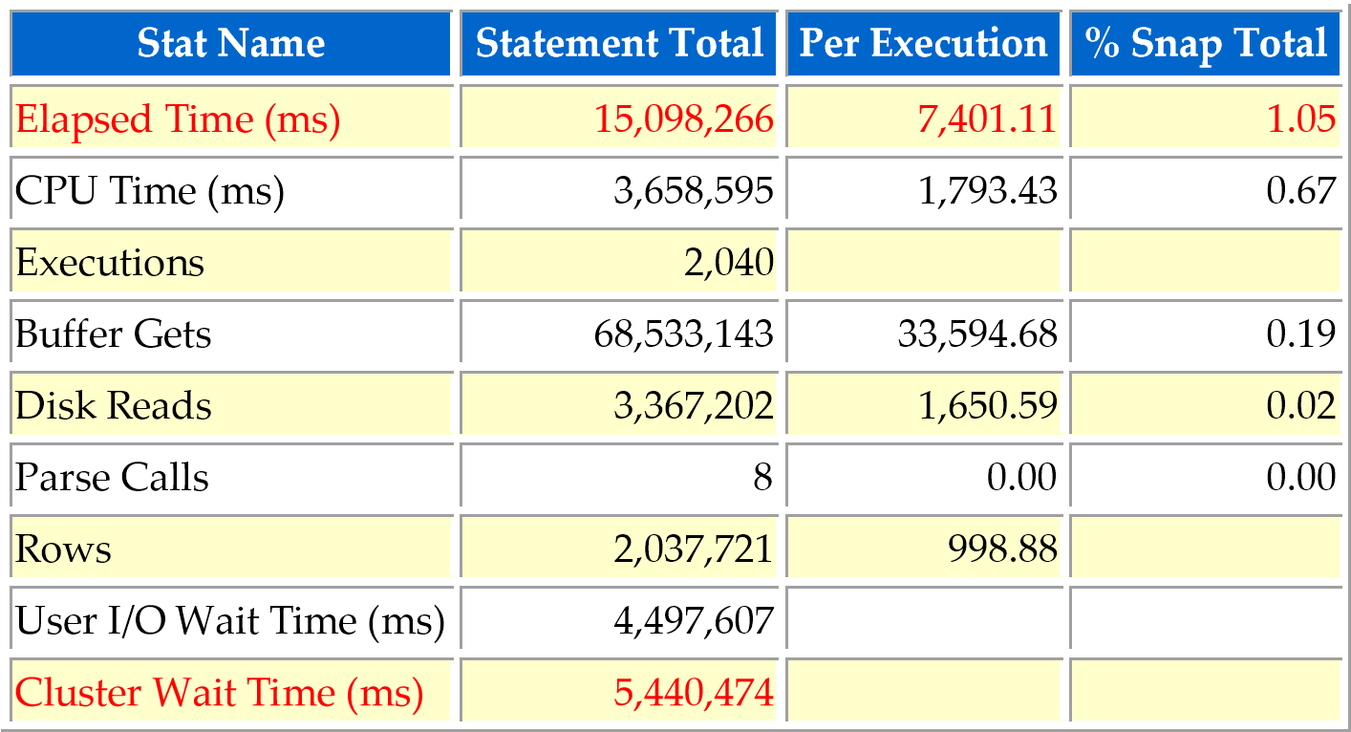

Cluster wait takes large portion of wait time. This is because different session/node insert to the same block which causes waits to modify same block.

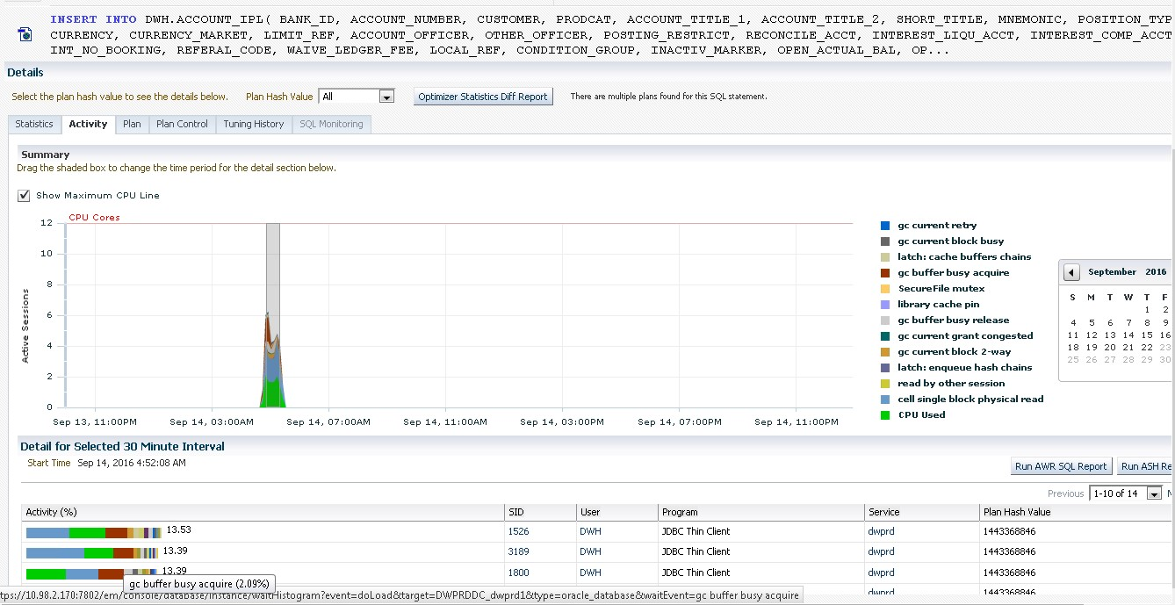

Table DWH.ACCOUNT_IPL: size 20.8 GB, 4,105,838 rows, non-partition.

Table also use COMPRESS FOR QUERY HIGH which affects DML performance. Compression is useful for table/partition with small changes only.

**Recommendation**: Partition table by HASH on column that can divide table effectively. Do not use COMPRESS on table/partition with high DML activity.

### SQL ID fty8ttr7ahz7p - Module ODI:1382949750338/7/2161002

UPDATE DWH.ECM_SWIFTTRANSACTION T

SET T.CURRENT_RECORD = 0, T.END_DATE = TO_DATE ('20160913', 'YYYYMMDD') WHERE ( (T.CASEID) IN (SELECT X.CASEID

FROM DWH_STAGING.I$_ECM_SWIFTTRANSACTION X

WHERE X.IND_UPDATE = 'U')

OR (T.CASEID) NOT IN (SELECT C1_CASEID CASEID

FROM DWH_STAGING.C$_0ECM_SWIFTTRANSACTION

WHERE (1 = 1)))

AND T.CURRENT_RECORD = 1

AND END_DATE = TO_DATE ('01-01-2400', 'mm-dd-yyyy')

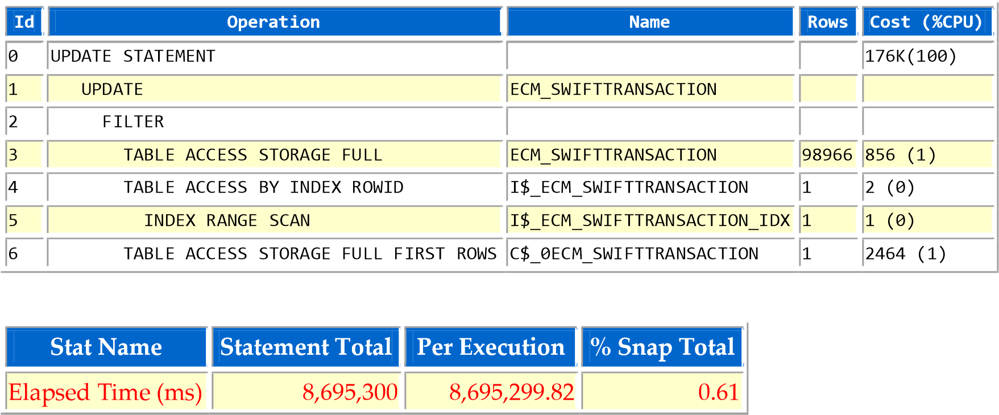

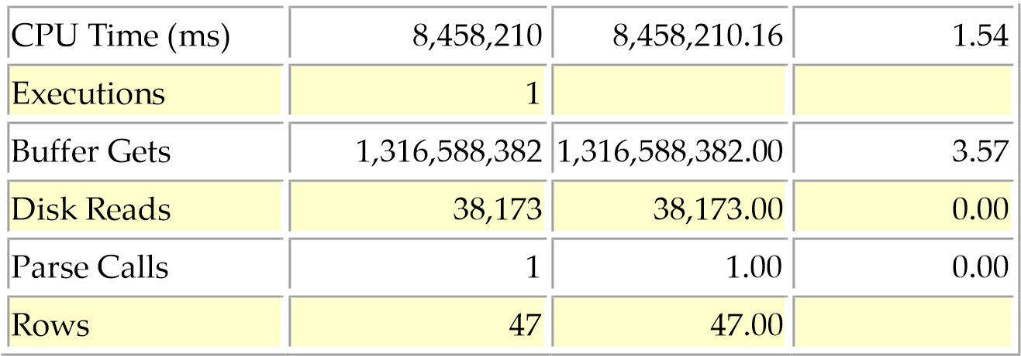

Each execution takes 144 minutes, process 9.8 TB.

Table DWH.ECM_SWIFTTRANSACTION size: 88MB, 100.169 rows, last analyze 2014/07/16, actual row count 303.626.

Table I$_ECM_SWIFTTRANSACTION is not found at data collection time.

**Recommendation**: Use hint to force FULL SCAN on I$_ECM_SWIFTTRANSACTION to reduce Buffer Gets.

### SQL ID 3f2t30tn75u8f - Module ODI:1382949750338/7/3751007

INSERT INTO DWH_STAGING.T_QUANLYTHE

(IDSEQ, BANK_ID, CARD_KEY, CUSTOMER_XL, ACCOUNT_XL, NAME_XL, LOAI_THE_XL,

LOAI_YEU_CAU, SO_THE_XL, NGUOI_XU_LY, NGAY_UPDATE, NGAY_XAC_NHAN,

NGAY_TRA_LAI_CN, NGAN_HANG_TRA, TEN_NH_TRA, DIA_CHI_ATM, NH_QLY_ATM,

LIMIT_CU, LIMIT_MOI, DESCRIPTION, COMPANY_WRITE, NGAY_YEU_CAU_XL,

SO_DIEN_THOAI, NGAY_XU_LY, GIO_XU_LY, TRANG_THAI_XL, ID_INFO_CARD,

CN_XU_LY, SO_MAY_ATM, LOAI_HINH_GD, AMOUNT_GD, SO_TIEN_GD, REMARK,

NGAY_GIAO_DICH, BALANCE_GD, SEQUENCE_XULY, BUOC_XU_LY, SO_TRACE,

TTHAI_JOUNAL, KT_XAC_NHAN, DIEN_GIAI, KE_TOAN_XN, VAN_HANH_XN,

KE_TOAN_HTRA, INPUT_NAME, AUTH_NAME, CURRENCY, SO_LAN_TRA_SOAT,

KT_CHU_KY_MAU, DIA_CHI_NHAN_SK, EMAIL, ACCOUNT_TT, DEBIT_AMOUNT, FREE_TXT,

NG_NHAN_KHOA_THE, RESERVED_12, RESERVED_13, RESERVED_14, RESERVED_15,

RESERVED_16, RESERVED_17, RESERVED_18, RESERVED_19, RESERVED_20,

TRANSACTION_TYPE, TRANSACTION_AMOUNT, RESERVED_23, RESERVED_24,

RESERVED_25, OVERRIDE, STMT_NOS, DELIVERY_REF, RECORD_STATUS, CURR_NO,

INPUTTER, DATE_TIME, AUTHORISER, CO_CODE, DEPT_CODE, AUDITOR_CODE, AUDIT_DATE_TIME)

SELECT SRC.IDSEQ IDSEQ, SRC.BANK_ID BANK_ID, SRC.CARD_KEY CARD_KEY,

SRC.CUSTOMER_XL CUSTOMER_XL, SRC.ACCOUNT_XL ACCOUNT_XL, SRC.NAME_XL NAME_XL,

SRC.LOAI_THE_XL LOAI_THE_XL, SRC.LOAI_YEU_CAU LOAI_YEU_CAU,

SRC.SO_THE_XL SO_THE_XL, SRC.NGUOI_XU_LY NGUOI_XU_LY,

SRC.NGAY_UPDATE NGAY_UPDATE, SRC.NGAY_XAC_NHAN NGAY_XAC_NHAN,

SRC.NGAY_TRA_LAI_CN NGAY_TRA_LAI_CN, SRC.NGAN_HANG_TRA NGAN_HANG_TRA,

SRC.TEN_NH_TRA TEN_NH_TRA, SRC.DIA_CHI_ATM DIA_CHI_ATM,

SRC.NH_QLY_ATM NH_QLY_ATM, SRC.LIMIT_CU LIMIT_CU, SRC.LIMIT_MOI LIMIT_MOI,

SRC.DESCRIPTION DESCRIPTION, SRC.COMPANY_WRITE COMPANY_WRITE,

SRC.NGAY_YEU_CAU_XL NGAY_YEU_CAU_XL, SRC.SO_DIEN_THOAI SO_DIEN_THOAI,

SRC.NGAY_XU_LY NGAY_XU_LY, SRC.GIO_XU_LY GIO_XU_LY,

SRC.TRANG_THAI_XL TRANG_THAI_XL, SRC.ID_INFO_CARD ID_INFO_CARD,

SRC.CN_XU_LY CN_XU_LY, SRC.SO_MAY_ATM SO_MAY_ATM,

SRC.LOAI_HINH_GD LOAI_HINH_GD, SRC.AMOUNT_GD AMOUNT_GD,

SRC.SO_TIEN_GD SO_TIEN_GD, SRC.REMARK REMARK,

SRC.NGAY_GIAO_DICH NGAY_GIAO_DICH, SRC.BALANCE_GD BALANCE_GD,

SRC.SEQUENCE_XULY SEQUENCE_XULY, SRC.BUOC_XU_LY BUOC_XU_LY,

SRC.SO_TRACE SO_TRACE, SRC.TTHAI_JOUNAL TTHAI_JOUNAL,

SRC.KT_XAC_NHAN KT_XAC_NHAN, SRC.DIEN_GIAI DIEN_GIAI,

SRC.KE_TOAN_XN KE_TOAN_XN, SRC.VAN_HANH_XN VAN_HANH_XN,

SRC.KE_TOAN_HTRA KE_TOAN_HTRA, SRC.INPUT_NAME INPUT_NAME,

SRC.AUTH_NAME AUTH_NAME, SRC.CURRENCY CURRENCY,

SRC.SO_LAN_TRA_SOAT SO_LAN_TRA_SOAT, SRC.KT_CHU_KY_MAU KT_CHU_KY_MAU,

SRC.DIA_CHI_NHAN_SK DIA_CHI_NHAN_SK, SRC.EMAIL EMAIL,

SRC.ACCOUNT_TT ACCOUNT_TT, SRC.DEBIT_AMOUNT DEBIT_AMOUNT,

SRC.FREE_TXT FREE_TXT, SRC.NG_NHAN_KHOA_THE NG_NHAN_KHOA_THE,

SRC.RESERVED_12 RESERVED_12, SRC.RESERVED_13 RESERVED_13,

SRC.RESERVED_14 RESERVED_14, SRC.RESERVED_15 RESERVED_15,

SRC.RESERVED_16 RESERVED_16, SRC.RESERVED_17 RESERVED_17,

SRC.RESERVED_18 RESERVED_18, SRC.RESERVED_19 RESERVED_19,

SRC.RESERVED_20 RESERVED_20, SRC.TRANSACTION_TYPE TRANSACTION_TYPE,

SRC.TRANSACTION_AMOUNT TRANSACTION_AMOUNT, SRC.RESERVED_23 RESERVED_23,

SRC.RESERVED_24 RESERVED_24, SRC.RESERVED_25 RESERVED_25,

SRC.OVERRIDE OVERRIDE, SRC.STMT_NOS STMT_NOS, SRC.DELIVERY_REF DELIVERY_REF,

SRC.RECORD_STATUS RECORD_STATUS, SRC.CURR_NO CURR_NO, SRC.INPUTTER INPUTTER,

SRC.DATE_TIME DATE_TIME, SRC.AUTHORISER AUTHORISER, SRC.CO_CODE CO_CODE,

SRC.DEPT_CODE DEPT_CODE, SRC.AUDITOR_CODE AUDITOR_CODE,

SRC.AUDIT_DATE_TIME AUDIT_DATE_TIME

FROM DWH.V_T24QUANLYTHE SRC

WHERE

IDSEQ BETWEEN :B2 AND :B1 LOG ERRORS REJECT LIMIT UNLIMITED

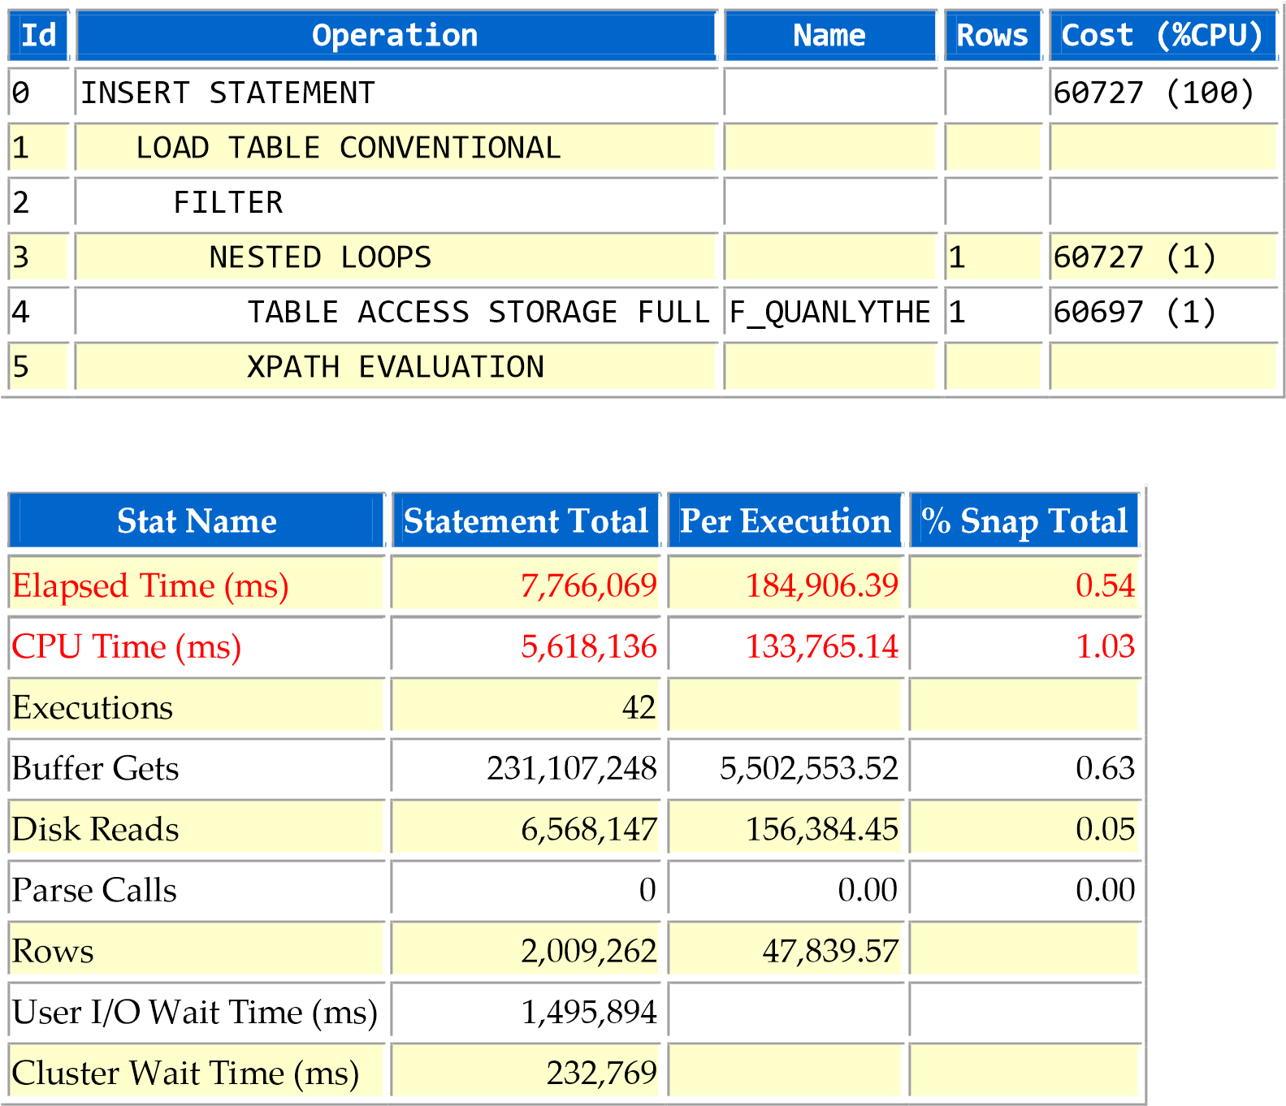

CPU takes 72% of execution time. This is mostly because XPATH EVALUATION step. To reduce CPU usage, we will limit rows to process by use index on IDSEQ column.

Table DWH_BK.F_QUANLYTHE: 2.23 GB, 3171879 rows, no statistics.

Create index on IDSEG:

CREATE UNIQUE INDEX DWH_BK.F_QUANLYTHE_IDSEQ_I

ON DWH_BK.F_QUANLYTHE (IDSEQ)

TABLESPACE DWH_BK ONLINE;

New execution plan:

Plan hash value: 4228470407

------------------------------------------------------------------------------------------------------

| Id | Operation | Name | Rows | Bytes | Cost (%CPU)| Time |

------------------------------------------------------------------------------------------------------

| 0 | INSERT STATEMENT | | 4284K| 9405M| 290K (1)| 00:00:08 |

| 1 | LOAD TABLE CONVENTIONAL | T_QUANLYTHE | | | | |

|* 2 | FILTER | | | | | |

| 3 | NESTED LOOPS | | 4284K| 9405M| 290K (1)| 00:00:08 |

| 4 | TABLE ACCESS BY INDEX ROWID| F_QUANLYTHE | 10490 | 21M| 4716 (1)| 00:00:01 |

|* 5 | INDEX RANGE SCAN | F_QUANLYTHE_IDSEQ_I | 18882 | | 36 (0)| 00:00:01 |

|* 6 | XPATH EVALUATION | | | | | | -------------------------------------------------------------------------------------------------

Predicate Information (identified by operation id):

---------------------------------------------------

2 - filter(TO_NUMBER(:B1)>=TO_NUMBER(:B2))

5 - access("X"."IDSEQ">=TO_NUMBER(:B2) AND "X"."IDSEQ"<=TO_NUMBER(:B1)) 6 - filter("P"."C_01$" IS NOT NULL)

Less rows will process with XPATH EVALUATION & CPU usage will be lower.

**Recommendation**: Create unique index on F_QUANLYTHE (IDSEQ).

### SQL ID bfznkpy3atxm1 - Module ODI:1382949750338/7/7346007

SELECT */*+DRIVING_SITE(v24)*/*

SEQ,

RECID,

XMLRECORD,

TO_DATE ('20160913', 'YYYYMMDD')

FROM V24_QUANLY_INFO_UPDATE_LKGD@T24DWH V24

WHERE SEQ BETWEEN :B2 AND :B1

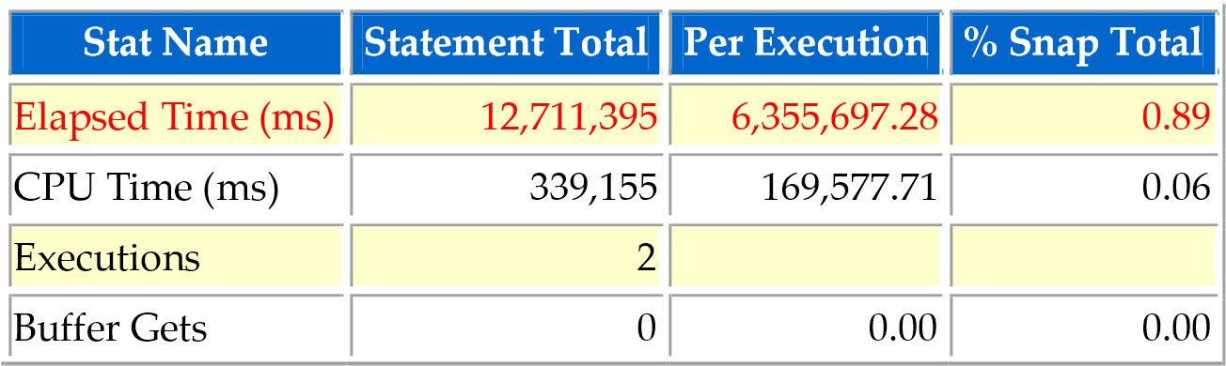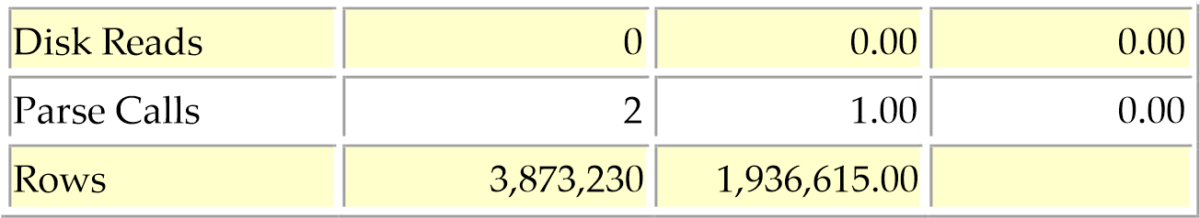

Each execution takes 100 minutes.

The query actually runs on T24DWH database link which is COBR14DR instance.

Execution plan at remote site:

-------------------------------------------------------------------------------------------------------------

| Id | Operation | Name | Rows | Bytes | Cost (%CPU)| Time |

-------------------------------------------------------------------------------------------------------------

| 0 | SELECT STATEMENT | | 23750 | 15M| 16070 (3)| 00:03:13 |

|* 1 | FILTER | | | | | |

| 2 | NESTED LOOPS | | 23750 | 15M| 16070 (3)| 00:03:13 |

| 3 | NESTED LOOPS | | 23750 | 15M| 16070 (3)| 00:03:13 |

|* 4 | TABLE ACCESS FULL | F24_QUANLY_INFO_UPDATE_LKGD | 23750 | 3293K| 15833 (3)| 00:03:10 |

|* 5 | INDEX UNIQUE SCAN | PK_FBNK_QUAN014 | 1 | | 1 (0)| 00:00:01 |

| 6 | TABLE ACCESS BY INDEX ROWID| FBNK_QUAN014 | 1 | 547 | 1 (0)| 00:00:01 | -------------------------------------------------------------------------------------------------------------

Predicate Information (identified by operation id):

---------------------------------------------------

1 - filter(TO_NUMBER(:B1)>=TO_NUMBER(:B2))

4 - filter("B"."SEQ">=TO_NUMBER(:B2) AND "B"."SEQ"<=TO_NUMBER(:B1)) 5 - access("A"."RECID"="B"."RECID")

Table T24_LIVE_DWH.F24_QUANLY_INFO_UPDATE_LKGD: no statistic, 448MB, 9.773.049 rows. Min SEQ: 1, Max SEQ: 9.773.049.

If :B2 and :B1 is a small range compare to above range, consider create index on F24_QUANLY_INFO_UPDATE_LKGD(SEQ) in COBR14DR to filter rows.

**Recommendation**: Consider create index on FF24_QUANLY_INFO_UPDATE_LKGD(SEQ). Similar SQL with high execution time:

SELECT */*+DRIVING_SITE(v24)*/*

SEQ,

RECID,

XMLRECORD,

TO_DATE ('20160912', 'YYYYMMDD')

FROM V24_PD_BALANCES@T24DWH V24

WHERE SEQ BETWEEN :B2 AND :B1

### SQL ID ca0vc3cbhjn0t - Module ODI:1382949750338/7/7425007

INSERT INTO DWH_STAGING.T_IC_HOME_BANKING_TCB

(IDSEQ, RECID, TERM, CHARGE_AMOUNT, DEBIT_ACCOUNT, PROCESSING_DATE, STMT_NO,

CHARGE_CODE, RESERVED_2, RESERVED_3, RESERVED_4, NOMINATED_ACCT, STATUS,

RESERVED_6, RESERVED_7, RESERVED_8, RESERVED_9, RESERVED_10, PENDING,

OVERRIDE, RECORD_STATUS, CURR_NO, INPUTTER, DATE_TIME, AUTHORISER, CO_CODE,

DEPT_CODE, AUDITOR_CODE, AUDIT_DATE_TIME)

SELECT SRC.IDSEQ IDSEQ, SRC.RECID RECID, SRC.TERM TERM,

SRC.CHARGE_AMOUNT CHARGE_AMOUNT, SRC.DEBIT_ACCOUNT DEBIT_ACCOUNT,

SRC.PROCESSING_DATE PROCESSING_DATE, SRC.STMT_NO STMT_NO,

SRC.CHARGE_CODE CHARGE_CODE, SRC.RESERVED_2 RESERVED_2, SRC.RESERVED_3 RESERVED_3, SRC.RESERVED_4 RESERVED_4,

SRC.NOMINATED_ACCT NOMINATED_ACCT, SRC.STATUS STATUS,

SRC.RESERVED_6 RESERVED_6, SRC.RESERVED_7 RESERVED_7,

SRC.RESERVED_8 RESERVED_8, SRC.RESERVED_9 RESERVED_9,

SRC.RESERVED_10 RESERVED_10, SRC.PENDING PENDING, SRC.OVERRIDE OVERRIDE,

SRC.RECORD_STATUS RECORD_STATUS, SRC.CURR_NO CURR_NO, SRC.INPUTTER INPUTTER,

SRC.DATE_TIME DATE_TIME, SRC.AUTHORISER AUTHORISER, SRC.CO_CODE CO_CODE,

SRC.DEPT_CODE DEPT_CODE, SRC.AUDITOR_CODE AUDITOR_CODE,

SRC.AUDIT_DATE_TIME AUDIT_DATE_TIME

FROM DWH.V_T24IC_HOME_BANKING_TCB SRC

WHERE

IDSEQ BETWEEN :B2 AND :B1 LOG ERRORS REJECT LIMIT UNLIMITED

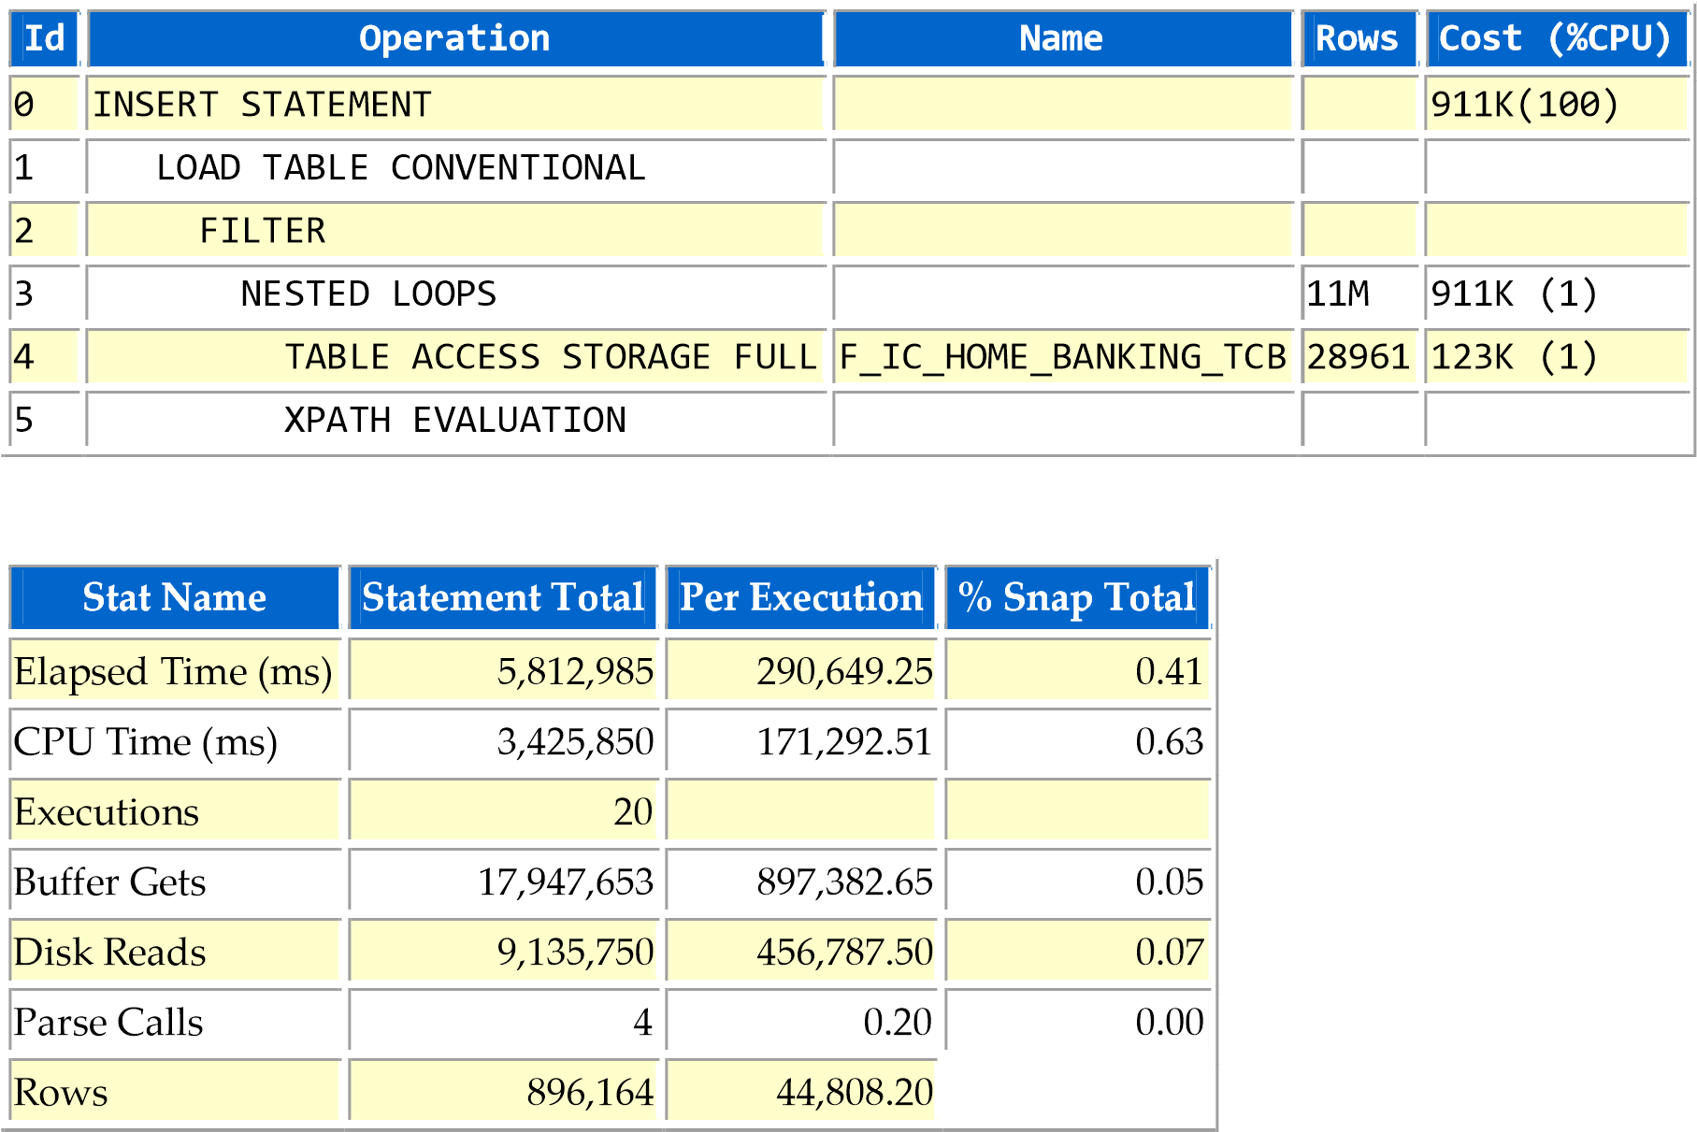

TABLE DWH_BK.F_IC_HOME_BANKING_TCB: Size 4.24 GB, 2240413 rows, no statistics.

**Recommendation**: Create index on F_IC_HOME_BANKING_TCB(IDSEQ).

### SQL ID 105jxp6m8chwv - Module ODI:1382949750338/7/3776007

INSERT INTO DWH_STAGING.T_STMT_ENTRY

(IDSEQ, STMT_ENTRY_ID, ACCOUNT_NUMBER, COMPANY_CODE, AMT_LCY, TRANSACTION_CODE,

THEIR_REFERENCE, NARRATIVE, PL_CATEGORY, CUSTOMER_ID, ACCOUNT_OFFICER,

PRODUCT_CATEGORY, VALUE_DATE, CURRENCY, AMOUNT_FCY, EXCHANGE_RATE,

NEGOTIATED_REF_NUM, POSITION_TYPE, OUR_REFERENCE, REVERSAL_MARKER,

EXPOSURE_DATE, CURRENCY_MARKET, LOCAL_REF, DEPARTMENT_CODE,

TRANS_REFERENCE, SYSTEM_ID, BOOKING_DATE, STMT_NO, OVERRIDE, RECORD_STATUS,

CURR_NO, ADJ, ADJ_DATE, INPUTTER, DATE_TIME, AUTHORISER, SUSPENSE_CATEGORY,

SUSPNSE_VALUE_DATE, SUPPRESS_POSITION, CRF_TYPE, CRF_TXN_CODE,

CRF_CURRENCY, CONSOL_KEY, CRF_MAT_DATE, CRF_PROD_CAT, PM_TYPE, DEALER_DESK,

COUNTERPARTY, LIQUIDATION_MODE, REPAYMENT_DATE, REPAYMENT_TYPE,

REPAYMENT_AMT, OUTSTANDING_BAL, CONTRACT_INT_RATE, CONTRACT_INT_KEY,

CYCLE_FORWARD, ORIG_LOCAL_EQUIV, ORIGINAL_AMOUNT, ORIGINAL_CCY,

ORIGINAL_ACCT, ORIGINAL_EXCH_RATE, EXP_SPLIT_DATE, EXP_SPLIT_AMT,

ORIG_AMOUNT_LCY, BANK_SORT_CDE, CHEQUE_NUMBER, CHQ_COLL_ID, DRAWN_ACCOUNT,

ACCOUNTING_DATE, PC_PERIOD_END, PC_APPLIED, PROCESS_FORWARD,

AA_SUSPENSE_REF, POS_EXP_DATE, RC_DETAIL_ID, TAX_DATA, CUS_PL_ACCOUNT,

RESERVED_9, RESERVED_10, AMOUNT_DEAL_CCY, DEAL_CCY, DEAL_EXCH_RATE,

MASK_PRINT, MASK_NARRATIVE, STMT1_DATE, STMT2_DATE, CHQ_TYPE,

TAX_EXCH_RATE, NET_PARAM, MASTER_ACCOUNT, ADDL_TRANS_REF, INTEREST_RATE,

DD_MANDATE_REF, DD_ITEM_REF, DD_MANDATE_DATE, CONTRACT_BAL_ID, TRADE_DATE,

PROCESSING_DATE, BALANCE_TYPE, AA_ITEM_REF, ACCRUAL_DATA, ORIG_CCY_MARKET,

CARD_NUMBER, CARD_TXN_DETAIL, DRAFT_PAYEE_NAME, BANK_ID)

SELECT SRC.IDSEQ IDSEQ, SRC.STMT_ENTRY_ID STMT_ENTRY_ID,

NVL (SRC.ACCOUNT_NUMBER, '***') ACCOUNT_NUMBER,

NVL (SRC.COMPANY_CODE, '***') COMPANY_CODE, SRC.AMT_LCY AMT_LCY,

NVL (SRC.TRANSACTION_CODE, -1) TRANSACTION_CODE,

SRC.THEIR_REFERENCE THEIR_REFERENCE, SRC.NARRATIVE NARRATIVE,

SRC.PL_CATEGORY PL_CATEGORY, NVL (SRC.CUSTOMER_ID, -1) CUSTOMER_ID,

NVL (SRC.ACCOUNT_OFFICER, -1) ACCOUNT_OFFICER,

NVL (SRC.PRODUCT_CATEGORY, -1) PRODUCT_CATEGORY, SRC.VALUE_DATE VALUE_DATE,

NVL (SRC.CURRENCY, '***') CURRENCY, SRC.AMOUNT_FCY AMOUNT_FCY,

SRC.EXCHANGE_RATE EXCHANGE_RATE, SRC.NEGOTIATED_REF_NUM NEGOTIATED_REF_NUM,

SRC.POSITION_TYPE POSITION_TYPE, SRC.OUR_REFERENCE OUR_REFERENCE,

SRC.REVERSAL_MARKER REVERSAL_MARKER, SRC.EXPOSURE_DATE EXPOSURE_DATE,

SRC.CURRENCY_MARKET CURRENCY_MARKET, SRC.LOCAL_REF LOCAL_REF,

NVL (SRC.DEPARTMENT_CODE, -1) DEPARTMENT_CODE,

NVL (SRC.TRANS_REFERENCE, '***') TRANS_REFERENCE, SRC.SYSTEM_ID SYSTEM_ID,

SRC.BOOKING_DATE BOOKING_DATE, SRC.STMT_NO STMT_NO, SRC.OVERRIDE OVERRIDE,

SRC.RECORD_STATUS RECORD_STATUS, SRC.CURR_NO CURR_NO, 'S' ADJ,

NULL ADJ_DATE, SRC.INPUTTER INPUTTER, SRC.DATE_TIME DATE_TIME,

SRC.AUTHORISER AUTHORISER, SRC.SUSPENSE_CATEGORY SUSPENSE_CATEGORY,

SRC.SUSPNSE_VALUE_DATE SUSPNSE_VALUE_DATE,

SRC.SUPPRESS_POSITION SUPPRESS_POSITION, SRC.CRF_TYPE CRF_TYPE,

SRC.CRF_TXN_CODE CRF_TXN_CODE, SRC.CRF_CURRENCY CRF_CURRENCY,

SRC.CONSOL_KEY CONSOL_KEY, SRC.CRF_MAT_DATE CRF_MAT_DATE,

SRC.CRF_PROD_CAT CRF_PROD_CAT, SRC.PM_TYPE PM_TYPE,

SRC.DEALER_DESK DEALER_DESK, SRC.COUNTERPARTY COUNTERPARTY,

SRC.LIQUIDATION_MODE LIQUIDATION_MODE, SRC.REPAYMENT_DATE REPAYMENT_DATE,

SRC.REPAYMENT_TYPE REPAYMENT_TYPE, SRC.REPAYMENT_AMT REPAYMENT_AMT,

SRC.OUTSTANDING_BAL OUTSTANDING_BAL,

SRC.CONTRACT_INT_RATE CONTRACT_INT_RATE,

SRC.CONTRACT_INT_KEY CONTRACT_INT_KEY, SRC.CYCLE_FORWARD CYCLE_FORWARD,

SRC.ORIG_LOCAL_EQUIV ORIG_LOCAL_EQUIV, SRC.ORIGINAL_AMOUNT ORIGINAL_AMOUNT,

SRC.ORIGINAL_CCY ORIGINAL_CCY, SRC.ORIGINAL_ACCT ORIGINAL_ACCT,

SRC.ORIGINAL_EXCH_RATE ORIGINAL_EXCH_RATE,

SRC.EXP_SPLIT_DATE EXP_SPLIT_DATE, SRC.EXP_SPLIT_AMT EXP_SPLIT_AMT,

SRC.ORIG_AMOUNT_LCY ORIG_AMOUNT_LCY, SRC.BANK_SORT_CDE BANK_SORT_CDE, SRC.CHEQUE_NUMBER CHEQUE_NUMBER, SRC.CHQ_COLL_ID CHQ_COLL_ID,

SRC.DRAWN_ACCOUNT DRAWN_ACCOUNT, SRC.ACCOUNTING_DATE ACCOUNTING_DATE,

SRC.PC_PERIOD_END PC_PERIOD_END, SRC.PC_APPLIED PC_APPLIED,

SRC.PROCESS_FORWARD PROCESS_FORWARD, SRC.AA_SUSPENSE_REF AA_SUSPENSE_REF,

SRC.POS_EXP_DATE POS_EXP_DATE, SRC.RC_DETAIL_ID RC_DETAIL_ID,

SRC.TAX_DATA TAX_DATA, SRC.CUS_PL_ACCOUNT CUS_PL_ACCOUNT,

SRC.RESERVED_9 RESERVED_9, SRC.RESERVED_10 RESERVED_10,

SRC.AMOUNT_DEAL_CCY AMOUNT_DEAL_CCY, SRC.DEAL_CCY DEAL_CCY,

SRC.DEAL_EXCH_RATE DEAL_EXCH_RATE, SRC.MASK_PRINT MASK_PRINT,

SRC.MASK_NARRATIVE MASK_NARRATIVE, SRC.STMT1_DATE STMT1_DATE,

SRC.STMT2_DATE STMT2_DATE, SRC.CHQ_TYPE CHQ_TYPE,

SRC.TAX_EXCH_RATE TAX_EXCH_RATE, SRC.NET_PARAM NET_PARAM,

SRC.MASTER_ACCOUNT MASTER_ACCOUNT, SRC.ADDL_TRANS_REF ADDL_TRANS_REF,

SRC.INTEREST_RATE INTEREST_RATE, SRC.DD_MANDATE_REF DD_MANDATE_REF,

SRC.DD_ITEM_REF DD_ITEM_REF, SRC.DD_MANDATE_DATE DD_MANDATE_DATE,

SRC.CONTRACT_BAL_ID CONTRACT_BAL_ID, SRC.TRADE_DATE TRADE_DATE,

SRC.PROCESSING_DATE PROCESSING_DATE, SRC.BALANCE_TYPE BALANCE_TYPE,

SRC.AA_ITEM_REF AA_ITEM_REF, SRC.ACCRUAL_DATA ACCRUAL_DATA, SRC.ORIG_CCY_MARKET ORIG_CCY_MARKET, SRC.CARD_NUMBER CARD_NUMBER,

SRC.CARD_TXN_DETAIL CARD_TXN_DETAIL, SRC.DRAFT_PAYEE_NAME DRAFT_PAYEE_NAME,

SRC.BANK_ID BANK_ID

FROM DWH.V_T24STMT_ENTRY SRC

WHERE

IDSEQ BETWEEN :B2 AND :B1 LOG ERRORS REJECT LIMIT UNLIMITED

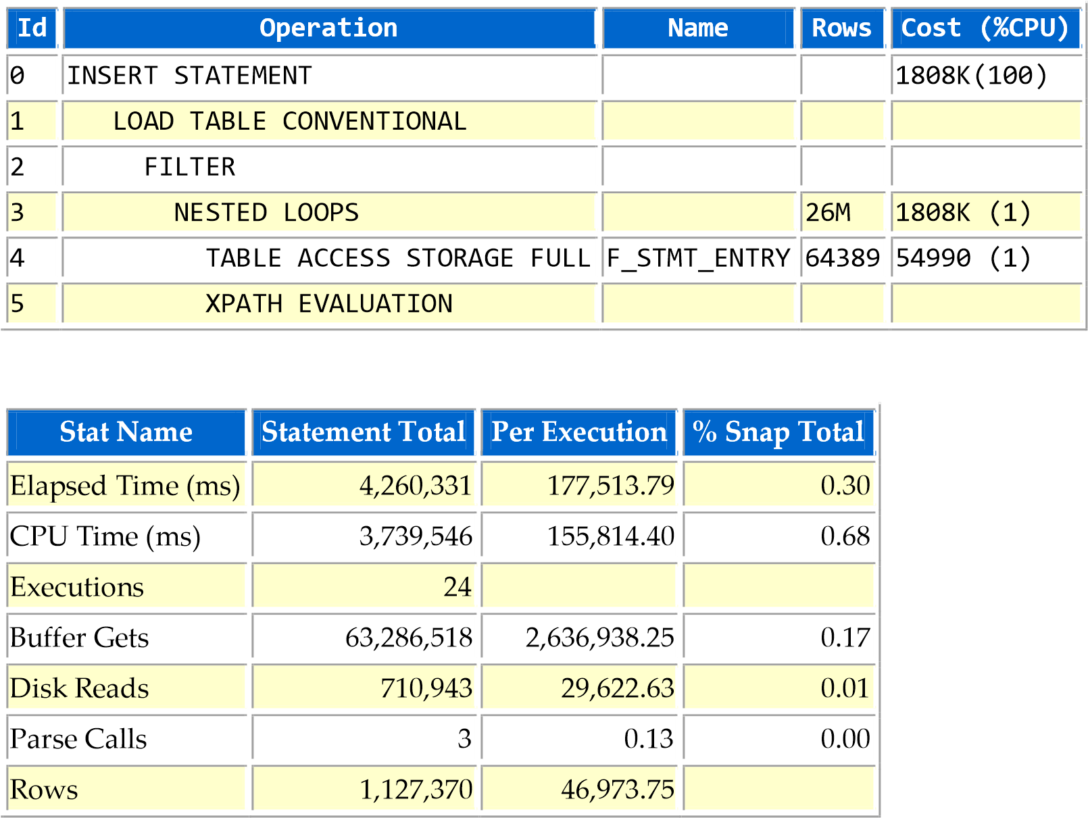

TABLE DWH_BK.F_STMT_ENTRY: Size 839 MB, 1.110.225 rows, no statistics.

**Recommendation**: Create index on F_STMT_ENTRY(IDSEQ).

### SQL ID 3s69um4a8x1ap - Module ODI:1382949750338/7/2777007

INSERT INTO DWH_STAGING.T_VISA_OFFUS_TCB(IDSEQ, REF_NO, CARD_NO, MERCHANT_ID, CURRENCY,

AMOUNT_LCY, AMOUNT_FCY, DEBIT_ACCT_NO, DEBIT_CURRENCY, CREDIT_ACCT_NO, CREDIT_CURRENCY,

TRANS_VALUE_DATE, POSTING_DATE, RESERVED_1, USE_VND, TRANS_CANCEL, NOTES, MGS_IN,

CREATE_DATE, MSG_DESCRIPTION, EXCHANGE_RATE, APP_CODE, USER_, COMPANY_CREDIT, CATEG_CR,

DEPT_OFFICER_CR, HACH_TOAN, MERCHANT_AMT, PL_AMT, VAT_AMT, TRANS_REF, TCB_MERCHANT, STMT_NO,

REVERSAL_MARKER, REFERENCE, LOCAL_REF, OVERRIDE, RECORD_STATUS, CURR_NO, INPUTTER,

DATE_TIME, AUTHORISER, CO_CODE, DEPT_CODE, AUDITOR_CODE, AUDIT_DATE_TIME)

SELECT SRC.IDSEQ IDSEQ, SRC.REF_NO REF_NO, SRC.CARD_NO CARD_NO,

SRC.MERCHANT_ID MERCHANT_ID, SRC.CURRENCY CURRENCY,

SRC.AMOUNT_LCY AMOUNT_LCY, SRC.AMOUNT_FCY AMOUNT_FCY,

SRC.DEBIT_ACCT_NO DEBIT_ACCT_NO, SRC.DEBIT_CURRENCY DEBIT_CURRENCY,

SRC.CREDIT_ACCT_NO CREDIT_ACCT_NO, SRC.CREDIT_CURRENCY CREDIT_CURRENCY,

SRC.TRANS_VALUE_DATE TRANS_VALUE_DATE, SRC.POSTING_DATE POSTING_DATE,

SRC.RESERVED_1 RESERVED_1, SRC.USE_VND USE_VND,

SRC.TRANS_CANCEL TRANS_CANCEL, SRC.NOTES NOTES, SRC.MGS_IN MGS_IN,

SRC.CREATE_DATE CREATE_DATE, SRC.MSG_DESCRIPTION MSG_DESCRIPTION,

SRC.EXCHANGE_RATE EXCHANGE_RATE, SRC.APP_CODE APP_CODE, SRC.USER_ USER_,

SRC.COMPANY_CREDIT COMPANY_CREDIT, SRC.CATEG_CR CATEG_CR,

SRC.DEPT_OFFICER_CR DEPT_OFFICER_CR, SRC.HACH_TOAN HACH_TOAN,

SRC.MERCHANT_AMT MERCHANT_AMT, SRC.PL_AMT PL_AMT, SRC.VAT_AMT VAT_AMT,

SRC.TRANS_REF TRANS_REF, SRC.TCB_MERCHANT TCB_MERCHANT, SRC.STMT_NO STMT_NO,

SRC.REVERSAL_MARKER REVERSAL_MARKER, SRC.REFERENCE REFERENCE,

SRC.LOCAL_REF LOCAL_REF, SRC.OVERRIDE OVERRIDE,

SRC.RECORD_STATUS RECORD_STATUS, SRC.CURR_NO CURR_NO, SRC.INPUTTER INPUTTER,

SRC.DATE_TIME DATE_TIME, SRC.AUTHORISER AUTHORISER, SRC.CO_CODE CO_CODE,

SRC.DEPT_CODE DEPT_CODE, SRC.AUDITOR_CODE AUDITOR_CODE,

SRC.AUDIT_DATE_TIME AUDIT_DATE_TIME

FROM DWH.V_T24VISA_OFFUS_TCB SRC

WHERE

IDSEQ BETWEEN :B2 AND :B1 LOG ERRORS REJECT LIMIT UNLIMITED

IDSEQ BETWEEN :B2 AND :B1 LOG ERRORS REJECT LIMIT UNLIMITED

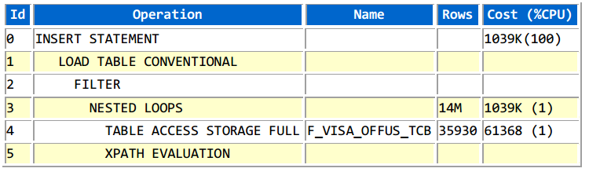

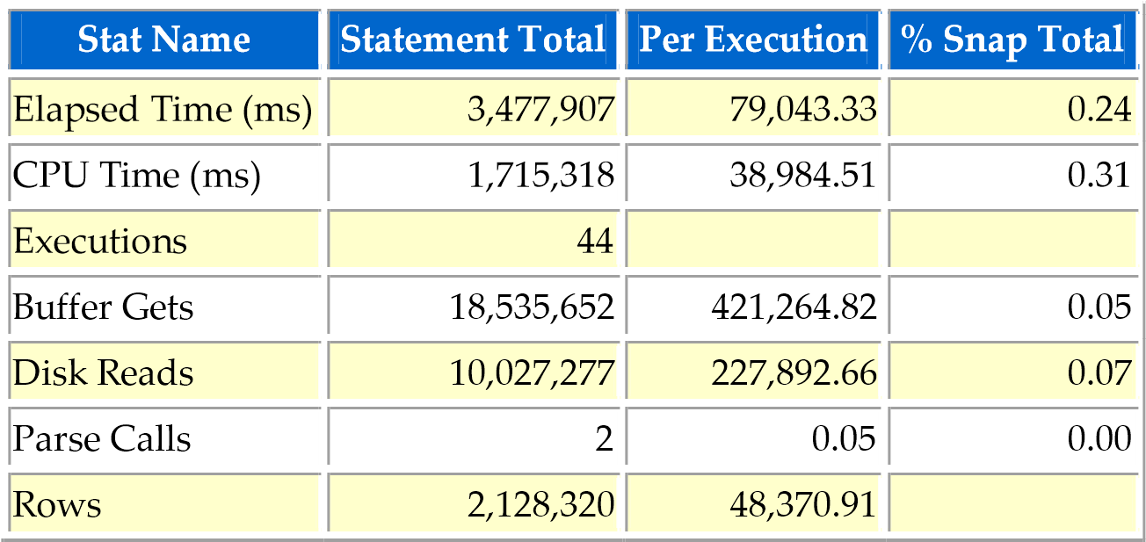

TABLE DWH_BK.F_VISA_OFFUS_TCB: Size 2.58 GB, 3.210.251 rows, no statistics.

**Recommendation**: Create index on F_VISA_OFFUS_TCB(IDSEQ).

### SQL ID dntcqtwbvpvv4 - Module ODI:1382949750338/7/7347007

INSERT INTO DWH_STAGING.T_VISA_OFFUS_TCB(IDSEQ, REF_NO, CARD_NO, MERCHANT_ID, CURRENCY,

AMOUNT_LCY, AMOUNT_FCY, DEBIT_ACCT_NO, DEBIT_CURRENCY, CREDIT_ACCT_NO, CREDIT_CURRENCY,

TRANS_VALUE_DATE, POSTING_DATE, RESERVED_1, USE_VND, TRANS_CANCEL, NOTES, MGS_IN,

CREATE_DATE, MSG_DESCRIPTION, EXCHANGE_RATE, APP_CODE, USER_, COMPANY_CREDIT, CATEG_CR,

DEPT_OFFICER_CR, HACH_TOAN, MERCHANT_AMT, PL_AMT, VAT_AMT, TRANS_REF, TCB_MERCHANT, STMT_NO,

REVERSAL_MARKER, REFERENCE, LOCAL_REF, OVERRIDE, RECORD_STATUS, CURR_NO, INPUTTER,

DATE_TIME, AUTHORISER, CO_CODE, DEPT_CODE, AUDITOR_CODE, AUDIT_DATE_TIME)

SELECT SRC.IDSEQ IDSEQ, SRC.REF_NO REF_NO, SRC.CARD_NO CARD_NO,

SRC.MERCHANT_ID MERCHANT_ID, SRC.CURRENCY CURRENCY,

SRC.AMOUNT_LCY AMOUNT_LCY, SRC.AMOUNT_FCY AMOUNT_FCY,

SRC.DEBIT_ACCT_NO DEBIT_ACCT_NO, SRC.DEBIT_CURRENCY DEBIT_CURRENCY,

SRC.CREDIT_ACCT_NO CREDIT_ACCT_NO, SRC.CREDIT_CURRENCY CREDIT_CURRENCY,

SRC.TRANS_VALUE_DATE TRANS_VALUE_DATE, SRC.POSTING_DATE POSTING_DATE,

SRC.RESERVED_1 RESERVED_1, SRC.USE_VND USE_VND,

SRC.TRANS_CANCEL TRANS_CANCEL, SRC.NOTES NOTES, SRC.MGS_IN MGS_IN,

SRC.CREATE_DATE CREATE_DATE, SRC.MSG_DESCRIPTION MSG_DESCRIPTION,

SRC.EXCHANGE_RATE EXCHANGE_RATE, SRC.APP_CODE APP_CODE, SRC.USER_ USER_,

SRC.COMPANY_CREDIT COMPANY_CREDIT, SRC.CATEG_CR CATEG_CR,

SRC.DEPT_OFFICER_CR DEPT_OFFICER_CR, SRC.HACH_TOAN HACH_TOAN,

SRC.MERCHANT_AMT MERCHANT_AMT, SRC.PL_AMT PL_AMT, SRC.VAT_AMT VAT_AMT,

SRC.TRANS_REF TRANS_REF, SRC.TCB_MERCHANT TCB_MERCHANT, SRC.STMT_NO STMT_NO,

SRC.REVERSAL_MARKER REVERSAL_MARKER, SRC.REFERENCE REFERENCE,

SRC.LOCAL_REF LOCAL_REF, SRC.OVERRIDE OVERRIDE,

SRC.RECORD_STATUS RECORD_STATUS, SRC.CURR_NO CURR_NO, SRC.INPUTTER INPUTTER,

SRC.DATE_TIME DATE_TIME, SRC.AUTHORISER AUTHORISER, SRC.CO_CODE CO_CODE,

SRC.DEPT_CODE DEPT_CODE, SRC.AUDITOR_CODE AUDITOR_CODE,

SRC.AUDIT_DATE_TIME AUDIT_DATE_TIME

FROM DWH.V_T24VISA_OFFUS_TCB SRC

WHERE

IDSEQ BETWEEN :B2 AND :B1 LOG ERRORS REJECT LIMIT UNLIMITED

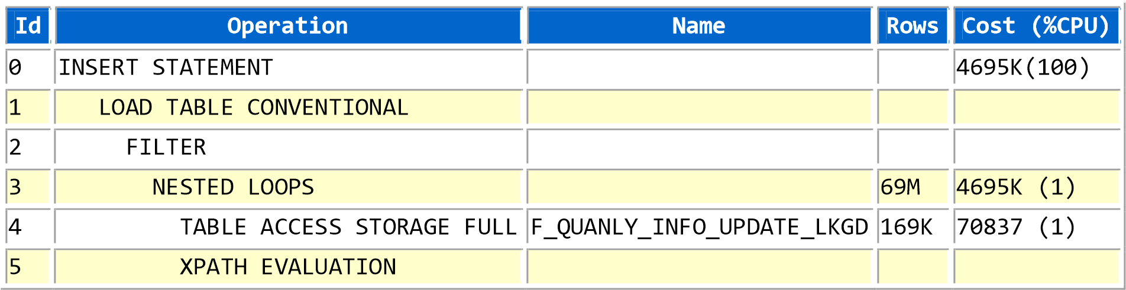

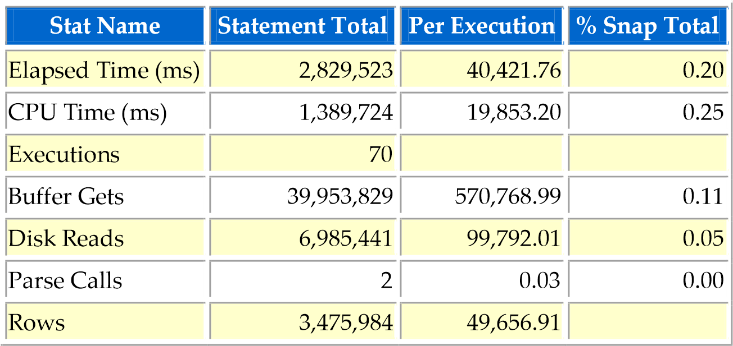

TABLE DWH_BK.F_QUANLY_INFO_UPDATE_LKGD: Size 2.64GB, 9.761.544 rows, no statistics.

**Recommendation**: Create index on F_QUANLY_INFO_UPDATE_LKGD(IDSEQ).

### SQL ID 4qjdnsbrp7xs2 - Module ODI:1382949750338/7/7373007

INSERT INTO DWH_STAGING.T_PD_BALANCES_HIST

(IDSEQ, BANK_ID, KEY, RECORD_START_DATE, CURRENCY, PAYMENT_STATUS,

PREVIOUS_STATUS, NO_DAYS_OVERDUE, BASE_EFF_DATE, BASE_AMOUNT,

RATE_EFF_DATE, RATE, POST_START_DATE, POST_END_DATE, BASE2_EFF_DATE,

BASE2_AMOUNT, RATE2_EFF_DATE, RATE2, POST2_START_DATE, POST2_END_DATE,

PEN_CALC_DATE, PEN_INT_CALC_AMT, PEN_INT_ACCR_AMT, PEN_INT_NAB_AMT,

PEN_INT2_CALC_AMT, PEN_INT2_ACCR_AMT, PEN_INT2_NAB_AMT, FROM_DATE_1,

TO_DATE_1, NO_DAYS_1, BASE_AMT_1, RATE_1, ACCR_AMT_1, ACCR_ACT_AMT_1,

POSTED_IND_1, FROM_DATE_2, TO_DATE_2, NO_DAYS_2, BASE_AMT_2, RATE_2,

ACCR_AMT_2, ACCR_ACT_AMT_2, POSTED_IND_2, AMT_TYPE, ORIGINAL_AMT,

CURR_OS_AMT, CURR_OS_TAX, CURR_OS_ACCR, CURR_OS_NAB, REPAY_DATE, REPAY_AMT,

ADJ_AMT, INT_REPAY_DATE, INT_REPAY_AMT, INT2_REPAY_DATE, INT2_REPAY_AMT,

CALC_START_DATE, RESERVED_6, RESERVED_5, RESERVED_4, RESERVED_3,

RESERVED_2, RESERVED_1)

SELECT SRC.IDSEQ IDSEQ, SRC.BANK_ID BANK_ID, SRC.KEY KEY,

SRC.RECORD_START_DATE RECORD_START_DATE, SRC.CURRENCY CURRENCY,

SRC.PAYMENT_STATUS PAYMENT_STATUS, SRC.PREVIOUS_STATUS PREVIOUS_STATUS,

SRC.NO_DAYS_OVERDUE NO_DAYS_OVERDUE, SRC.BASE_EFF_DATE BASE_EFF_DATE,

SRC.BASE_AMOUNT BASE_AMOUNT, SRC.RATE_EFF_DATE RATE_EFF_DATE, SRC.RATE RATE,

SRC.POST_START_DATE POST_START_DATE, SRC.POST_END_DATE POST_END_DATE,

SRC.BASE2_EFF_DATE BASE2_EFF_DATE, SRC.BASE2_AMOUNT BASE2_AMOUNT,

SRC.RATE2_EFF_DATE RATE2_EFF_DATE, SRC.RATE2 RATE2,

SRC.POST2_START_DATE POST2_START_DATE, SRC.POST2_END_DATE POST2_END_DATE,

SRC.PEN_CALC_DATE PEN_CALC_DATE, SRC.PEN_INT_CALC_AMT PEN_INT_CALC_AMT,

SRC.PEN_INT_ACCR_AMT PEN_INT_ACCR_AMT, SRC.PEN_INT_NAB_AMT PEN_INT_NAB_AMT,

SRC.PEN_INT2_CALC_AMT PEN_INT2_CALC_AMT,

SRC.PEN_INT2_ACCR_AMT PEN_INT2_ACCR_AMT,

SRC.PEN_INT2_NAB_AMT PEN_INT2_NAB_AMT, SRC.FROM_DATE_1 FROM_DATE_1,

SRC.TO_DATE_1 TO_DATE_1, SRC.NO_DAYS_1 NO_DAYS_1, SRC.BASE_AMT_1 BASE_AMT_1,

SRC.RATE_1 RATE_1, SRC.ACCR_AMT_1 ACCR_AMT_1,

SRC.ACCR_ACT_AMT_1 ACCR_ACT_AMT_1, SRC.POSTED_IND_1 POSTED_IND_1,

SRC.FROM_DATE_2 FROM_DATE_2, SRC.TO_DATE_2 TO_DATE_2,

SRC.NO_DAYS_2 NO_DAYS_2, SRC.BASE_AMT_2 BASE_AMT_2, SRC.RATE_2 RATE_2,

SRC.ACCR_AMT_2 ACCR_AMT_2, SRC.ACCR_ACT_AMT_2 ACCR_ACT_AMT_2,

SRC.POSTED_IND_2 POSTED_IND_2, SRC.AMT_TYPE AMT_TYPE,

SRC.ORIGINAL_AMT ORIGINAL_AMT, SRC.CURR_OS_AMT CURR_OS_AMT,

SRC.CURR_OS_TAX CURR_OS_TAX, SRC.CURR_OS_ACCR CURR_OS_ACCR,

SRC.CURR_OS_NAB CURR_OS_NAB, SRC.REPAY_DATE REPAY_DATE,

SRC.REPAY_AMT REPAY_AMT, SRC.ADJ_AMT ADJ_AMT,

SRC.INT_REPAY_DATE INT_REPAY_DATE, SRC.INT_REPAY_AMT INT_REPAY_AMT,

SRC.INT2_REPAY_DATE INT2_REPAY_DATE, SRC.INT2_REPAY_AMT INT2_REPAY_AMT,

SRC.CALC_START_DATE CALC_START_DATE, SRC.RESERVED_6 RESERVED_6,

SRC.RESERVED_5 RESERVED_5, SRC.RESERVED_4 RESERVED_4,

SRC.RESERVED_3 RESERVED_3, SRC.RESERVED_2 RESERVED_2,

SRC.RESERVED_1 RESERVED_1

FROM DWH.V_T24PD_BALANCES_HIST SRC

WHERE

IDSEQ BETWEEN :B2 AND :B1 LOG ERRORS REJECT LIMIT UNLIMITED

**Id**

**Operation**

**Name**

**Rows**

**Cost (%CPU)**

0

INSERT STATEMENT

1731K(100)

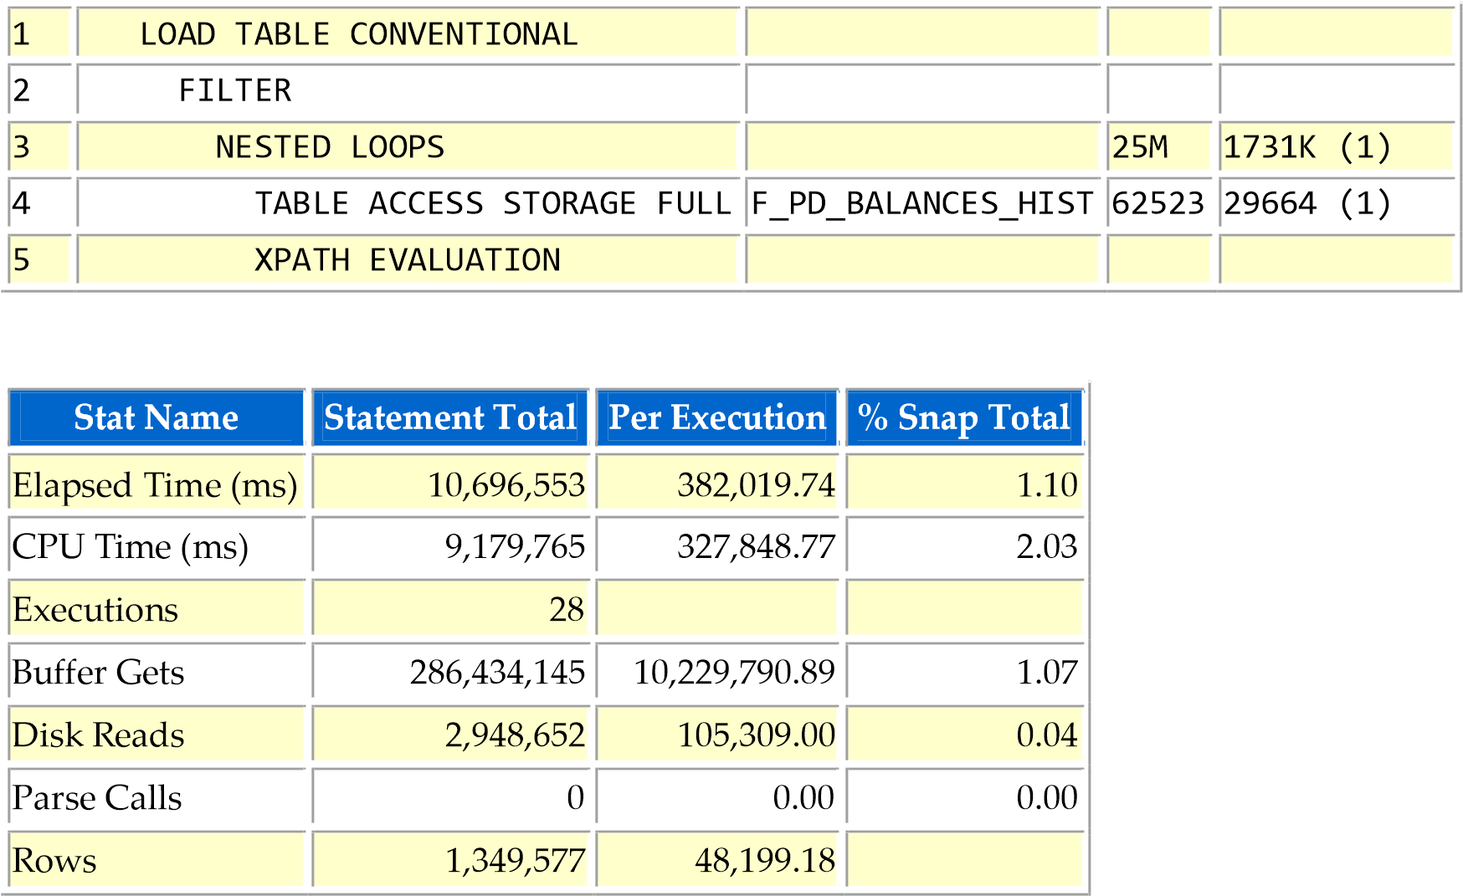

**Recommendation**: Create index on F_PD_BALANCES_HIST(IDSEQ).

### SQL ID d5dadbhtugtfq - Module ODI:1382949750338/7/8488007

INSERT INTO DWH.ACCOUNT

(BANK_ID, ACCOUNT_NUMBER, CUSTOMER, PRODCAT, ACCOUNT_TITLE_1, ACCOUNT_TITLE_2,

SHORT_TITLE, MNEMONIC, POSITION_TYPE, CURRENCY, CURRENCY_MARKET, LIMIT_REF,

ACCOUNT_OFFICER, OTHER_OFFICER, POSTING_RESTRICT, RECONCILE_ACCT,

INTEREST_LIQU_ACCT, INTEREST_COMP_ACCT, INT_NO_BOOKING, REFERAL_CODE,

WAIVE_LEDGER_FEE, LOCAL_REF, CONDITION_GROUP, INACTIV_MARKER,

OPEN_ACTUAL_BAL, OPEN_CLEARED_BAL, ONLINE_ACTUAL_BAL, ONLINE_CLEARED_BAL,

WORKING_BALANCE, DATE_LAST_CR_CUST, AMNT_LAST_CR_CUST, TRAN_LAST_CR_CUST,

DATE_LAST_CR_AUTO, AMNT_LAST_CR_AUTO, TRAN_LAST_CR_AUTO, DATE_LAST_CR_BANK,

AMNT_LAST_CR_BANK, TRAN_LAST_CR_BANK, DATE_LAST_DR_CUST, AMNT_LAST_DR_CUST,

TRAN_LAST_DR_CUST, DATE_LAST_DR_AUTO, AMNT_LAST_DR_AUTO, TRAN_LAST_DR_AUTO,

DATE_LAST_DR_BANK, AMNT_LAST_DR_BANK, TRAN_LAST_DR_BANK, CAP_DATE_CHARGE,

CAP_DATE_CR_INT, CAP_DATE_C2_INT, CAP_DATE_DR_INT, CAP_DATE_D2_INT,

CAP_BACK_VALUE, ACCR_CHG_CATEG, ACCR_CHG_TRANS, ACCR_CHG_AMOUNT,

ACCR_CHG_SUSP, ACCR_CR_CATEG, ACCR_CR_TRANS, ACCR_CR_AMOUNT, ACCR_CR_SUSP,

ACCR_CR2_CATEG, ACCR_CR2_TRANS, ACCR_CR2_AMOUNT, ACCR_CR2_SUSP,

ACCR_DR_CATEG, ACCR_DR_TRANS, ACCR_DR_AMOUNT, ACCR_DR_SUSP, ACCR_DR2_CATEG,

ACCR_DR2_TRANS, ACCR_DR2_AMOUNT, ACCR_DR2_SUSP, CONSOL_KEY, INT_LIQU_TYPE,

INT_LIQU_ACCT, INT_LIQ_CCY, PASSBOOK, START_YEAR_BAL, OPENING_DATE,

VALUE_DATE, CREDIT_MOVEMENT, DEBIT_MOVEMENT, VALUE_DATED_BAL,

CONTINGENT_BAL_CR, CONTINGENT_BAL_DR, OPEN_CATEGORY, OPEN_VAL_DATED_BAL,

ACCT_CREDIT_INT, ACCT_DEBIT_INT, LINK_TO_LIMIT, CLOSURE_DATE,

LOCKED_WITH_LIMIT, CHARGE_ACCOUNT, CHARGE_CCY, CHARGE_MKT, INTEREST_CCY,

INTEREST_MKT, CON_CHARGE_ACCR, CON_INTEREST_ACCR, ALT_ACCT_TYPE,

ALT_ACCT_ID, PREMIUM_TYPE, CAP_DATE_PRM, PREMIUM_FREQ, APR, JOINT_HOLDER,

RELATION_CODE, JOINT_NOTES, ALLOW_NETTING, LEDG_RECO_WITH, STMT_RECO_WITH,

OUR_EXT_ACCT_NO, RECO_TOLERANCE, PENDING_ID, TOTAL_PENDING,

STOCK_CONTROL_TYPE, SERIAL_NO_FORMAT, AUTO_PAY_ACCT, ORIG_CCY_PAYMENT,

AUTO_REC_CCY, ORIGINAL_ACCT, FROM_DATE, LOCKED_AMOUNT, DISPO_OFFICER,

DISPO_EXEMPT, TAX_SUSPEND, TAX_AT_SETTLE, ICA_MAIN_ACCOUNT,

ICA_DISTRIB_RATIO, ICA_MAIN_ACCT_IND, ICA_DISTRIB_TYPE, ICA_POST_INTEREST,

ICA_MAIN_RATIO, ICA_NEW_MAIN_ACC, ICA_START_DATE, ICA_ADD_REMOVE,

ICA_BACK_VALUE, ICA_MAIN_ACCT, ICA_MAIN_DATE, LIQUIDATION_MODE,

OVERDUE_STATUS, HVT_FLAG, SINGLE_LIMIT, CONTINGENT_INT, ALL_IN_ONE_PRODUCT,

ER_VALUE_DATE, ER_BALANCE, EP_BALANCE, SB_GROUP_ID, OPEN_AVAILABLE_BAL,

AVAILABLE_DATE, AV_AUTH_DB_MVMT, AV_NAU_DB_MVMT, AV_AUTH_CR_MVMT,

AV_NAU_CR_MVMT, AVAILABLE_BAL, FORWARD_MVMTS, CREDIT_CHECK,

AVAILABLE_BAL_UPD, CONSOLIDATE_ENT, MAX_SUB_ACCOUNT, MASTER_ACCOUNT,

LOCK_INC_THIS_MVMT, CLOSED_ONLINE, NEXT_AF_DATE, NEXT_ACCT_CAP,

NEXT_EXP_DATE, DATE_LAST_UPDATE, NEXT_STMT_DATE, EXPOSURE_DATES,

PORTFOLIO_NO, SHADOW_ACCOUNT, FWD_ENTRY_HOLD, FIRST_AF_DATE,

CASH_POOL_GROUP, OPEN_ASSET_TYPE, LAST_COM_CHG_DATE, IC_CHARGE_ID,

IC_NEXT_CAP_DATE, IC_PRODUCT, IC_LST_PROD_CAP, ARRANGEMENT_ID,

ACC_DEB_LIMIT, MANDATE_APPL, MANDATE_REG, MANDATE_RECORD, DR_ADJ_AMOUNT,

DR2_ADJ_AMOUNT, CR_ADJ_AMOUNT, CR2_ADJ_AMOUNT, EVENT, FIELD, OPERAND,

VALUE, MV_ALERT_RES6, MV_ALERT_RES5, MV_ALERT_RES4, MV_ALERT_RES3,

MV_ALERT_RES2, MV_ALERT_RES1, REQUEST_ID, OVERRIDE, RECORD_STATUS, CURR_NO,

INPUTTER, DATE_TIME, AUTHORISER, CO_CODE, DEPT_CODE, AUDITOR_CODE, AUDIT_DATE_TIME, PROCESS_DATE)

VALUES

(:B1, :B2, :B3, :B4, :B5, :B6, :B7, :B8, :B9, :B10, :B11, :B12, :B13, :B14, :B15,

:B16, :B17, :B18, :B19, :B20, :B21, :B22, :B23, :B24, :B25, :B26, :B27,

:B28, :B29, :B30, :B31, :B32, :B33, :B34, :B35, :B36, :B37, :B38, :B39,

:B40, :B41, :B42, :B43, :B44, :B45, :B46, :B47, :B48, :B49, :B50, :B51,

:B52, :B53, :B54, :B55, :B56, :B57, :B58, :B59, :B60, :B61, :B62, :B63,

:B64, :B65, :B66, :B67, :B68, :B69, :B70, :B71, :B72, :B73, :B74, :B75,

:B76, :B77, :B78, :B79, :B80, :B81, :B82, :B83, :B84, :B85, :B86, :B87,

:B88, :B89, :B90, :B91, :B92, :B93, :B94, :B95, :B96, :B97, :B98, :B99,

:B100, :B101, :B102, :B103, :B104, :B105, :B106, :B107, :B108, :B109,

:B110, :B111, :B112, :B113, :B114, :B115, :B116, :B117, :B118, :B119,

:B120, :B121, :B122, :B123, :B124, :B125, :B126, :B127, :B128, :B129,

:B130, :B131, :B132, :B133, :B134, :B135, :B136, :B137, :B138, :B139,

:B140, :B141, :B142, :B143, :B144, :B145, :B146, :B147, :B148, :B149,

:B150, :B151, :B152, :B153, :B154, :B155, :B156, :B157, :B158, :B159,

:B160, :B161, :B162, :B163, :B164, :B165, :B166, :B167, :B168, :B169,

:B170, :B171, :B172, :B173, :B174, :B175, :B176, :B177, :B178, :B179,

:B180, :B181, :B182, :B183, :B184, :B185, :B186, :B187, :B188, :B189,

:B190, :B191, :B192, :B193, :B194, :B195, :B196, :B197, :B198, :B199,

:B200, :B201, :B202, :B203, :B204, :B205, :B206, :B207, :B208, :B209, :B210, :B211, :B212, :B213)

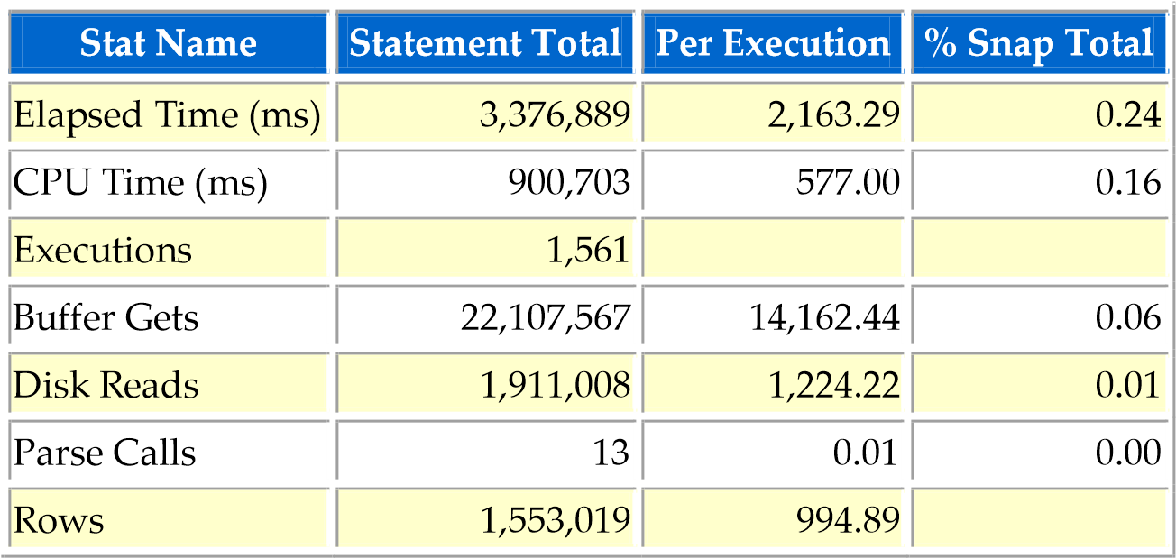

It takes 2 second for an INSERT which is quite slow.

TABLE DWH.ACCOUNT: Size 321 GB, 733.011.491 rows, partition by interval 1 day on PROCESS_DATE. Table use COMPRESS FOR QUERY HIGH for all partition that will affect DML performance.

**Recommendation**: Do not COMPRESS partition with high number of DML activity

### SQL ID 6a2ay1m4fzkzu - Module ODI:1382949750338/7/2483007

INSERT */*+append nologging */*

INTO R_TBL_AC_0009

SELECT ACC.ACCOUNT_NUMBER ACCOUNT_NUMBER, ACC.ACCOUNT_TITLE_1 ACCOUNT_TITLE,

(SELECT COM.MNEMONIC

FROM DWH.COMPANY COM

WHERE

COM.COMPANY_CODE = ACC.CO_CODE) COMPANY_MNE,

(SELECT DWH.SPLIT_COL (COM.COMPANY_NAME, 1)

FROM DWH.COMPANY COM

WHERE

COM.COMPANY_CODE = ACC.CO_CODE) COMPANY_NAME, ACC.MNEMONIC,

ACC.CUSTOMER, DWH.SPLIT_COL (ACC.ALT_ACCT_ID, 1) ALT_ACCT_ID,

DWH.SPLIT_COL (CUS.NAME_1, 1) CUS_NAME, ACC.CURRENCY, ACC.PRODCAT CATEGORY,

CONCAT (CONCAT (ACC.CUSTOMER, '.0000'), ACC.LIMIT_REF) LIMIT_ID,

LIM.ONLINE_LIMIT_DATE, LIM.EXPIRY_DATE,

NVL (DWH.SPLIT_COL (LIM.ONLINE_LIMIT, 1), 0) ONLINE_LIMIT,

ACC.WORKING_BALANCE, ACC.ONLINE_ACTUAL_BAL, ACC.OPEN_ACTUAL_BAL,

(CASE

WHEN (SPLIT_COL (ACC.POSTING_RESTRICT) <> '80') THEN TO_CHAR ( NVL

(TCB_DWH_VAS.FNC_GET_MAX (ACC.LOCKED_AMOUNT), 0))

ELSE 'TOAN BO SO DU'

END) AS SO_TIEN_PHONG_TOA,

(CASE

WHEN (ACC.FROM_DATE LIKE '%99990909%') THEN TO_NUMBER ( DWH.SPLIT_COL (

ACC.LOCKED_AMOUNT, TCB_DWH_VAS.GET_POS_MV (ACC.FROM_DATE, '99990909')))

WHEN (ACC.FROM_DATE LIKE '%10000101%') THEN TO_NUMBER ( DWH.SPLIT_COL ( ACC.LOCKED_AMOUNT, TCB_DWH_VAS.GET_POS_MV (ACC.FROM_DATE, '10000101')))

ELSE 0

END) AS PHONG_TOA_THE,

CASE

WHEN (NVL (DWH.SPLIT_COL (LIM.ONLINE_LIMIT, 1), 0) = 0) THEN 0

ELSE (

CASE

WHEN (NVL (ACC.WORKING_BALANCE, 0) >= 0) THEN TO_NUMBER ( NVL (DWH.SPLIT_COL (LIM.ONLINE_LIMIT, 1), 0))

ELSE TO_NUMBER ( NVL (DWH.SPLIT_COL (LIM.ONLINE_LIMIT, 1), 0)) + NVL

(ACC.WORKING_BALANCE, 0)

END)

END AS HM_CON_LAI, CUS.SECTOR SECTOR,

(SELECT DWH.SPLIT_COL (SEC.LOCAL_REF, 1)

FROM DWH.SECTOR SEC

WHERE

SEC.SECTOR_CODE = CUS.SECTOR) BIZLINE,

DWH.SPLIT_COL (CUS.LOCAL_REF, 20) CITY_REGID,

DWH.SPLIT_COL (CUS.LOCAL_REF, 34) DKKD, ACC.ACCOUNT_OFFICER,

DWH.SPLIT_COL (ACC.LOCAL_REF, 14) TCB_DEPARTMENT, ACC.CONSOL_KEY,

DWH.SPLIT_COL (ACC.LOCAL_REF, 26) LAI_SUAT_KH,

(SELECT DWH.SPLIT_COL (IND.DESCRIPTION, 1)

FROM DWH.INDUSTRY IND

WHERE

IND.INDUSTRY_CODE = CUS.INDUSTRY) INDUSTRY,

DWH.SPLIT_COL (ACC.LOCAL_REF, 23) ATM,

DWH.SPLIT_COL (ACC.LOCAL_REF, 48) ID_CONG_TY,

(SELECT DWH.SPLIT_COL (CUS.SHORT_NAME, 2)

FROM DWH.CUSTOMER CUS

WHERE

DWH.SPLIT_COL (ACC.LOCAL_REF, 48) = CUS.CUSTOMER_CODE) TEN_CONG_TY,

DWH.SPLIT_COL (ACC.LOCAL_REF, 44) TK_SALE,

DWH.SPLIT_COL (ACC.LOCAL_REF, 41) TCB_PRODUCT, ACC.DATE_LAST_DR_CUST,

ACC.DATE_LAST_CR_CUST, ACC.CONDITION_GROUP,

DWH.SPLIT_COL (ACC.LOCAL_REF, 2) TERM_START_DATE,

DWH.SPLIT_COL (ACC.JOINT_HOLDER, 1) JOINT_HOLDER,

REPLACE (CONVERT_MV_CLOB (FROM_DATE), '|', ', ') FROM_DATE, ACC.CO_CODE FROM DWH.ACCOUNT ACC, DWH.CUSTOMER CUS, DWH.LIMIT LIM

WHERE

ACC.PROCESS_DATE = :B1

AND ACC.PRODCAT <> 1006

AND ACC.CUSTOMER = CUS.CUSTOMER_CODE(+)

AND CONCAT (CONCAT (ACC.CUSTOMER, '.0000'), ACC.LIMIT_REF) = LIM.LIMIT_ID(+)

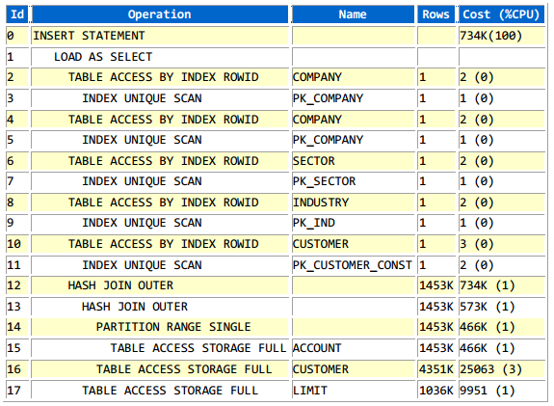

**Stat Name Snap Total**

Elapsed Time (ms) 2,991,443 2,991,443.07 0.21

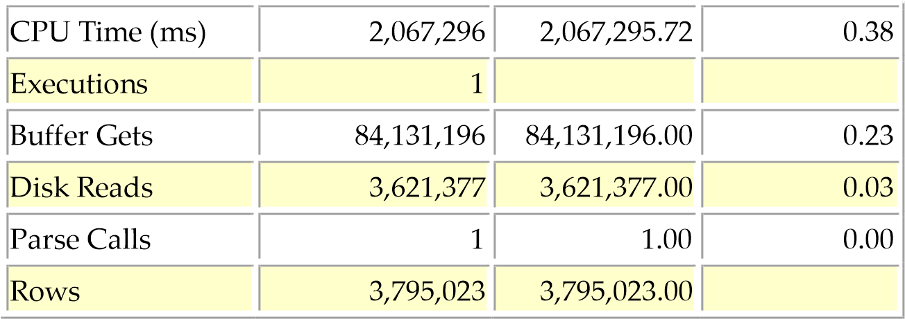

The SQL takes 50 minutes to finish.

We can use parallel feature to decrease execution time with hint as below:

INSERT */*+ append nologging */* INTO R_TBL_AC_0009

SELECT */*+ PARALLEL(32) */* ACC.ACCOUNT_NUMBER ACCOUNT_NUMBER, ACC.ACCOUNT_TITLE_1 ACCOUNT_TITLE,

(SELECT COM.MNEMONIC

FROM DWH.COMPANY COM

WHERE COM.COMPANY_CODE = ACC.CO_CODE) COMPANY_MNE,

**Recommendation**: Test SQL with PARALLEL hint & apply to source code.